LC/MS Analysis of the Serotonin Knockout Rat Hippocampus: An Untargeted Metabolomics Protocol
Henry Chafee – 300520727

PSYC 489 Research Project

Victoria University of Wellington

Word count: 7,894

Acknowledgements: special thanks goes to Professor Bart Ellenbroek for supervising this project; Dr. Joyce Colussi-Mas in the Psychology Department for providing her indispensable guidance and advice; and Professor Rob Keyzers and Dr. Jan Vorster in the Chemistry Department for providing their technical expertise.
Abstract
Serotonin knockout animals are a mutant strain of rats that have been genetically manipulated to exhibit reduced or abolished serotonin transporter function. Untargeted metabolomics is a hypothesis-generating protocol that utilizes analytical platforms to quantify metabolites in biological samples. This study employed liquid chromatography mass spectrometry (LC/MS) in order to determine whether the quantity of any specific metabolic features differed significantly as a function of serotonin knockout genotype. Due to technical issues, no conclusions could be drawn from the data. However, this study did successfully develop and optimize a sample preparation procedure for analyzing rodent brain tissue with LC/MS. The study also succeeded in developing an optimized protocol for processing raw analytical data to reduce potentially confounding effects. Finally, the study revealed that age of the animal at the time of sample collection is a salient factor, and one that future metabolomics studies should either control for or assess directly.

Introduction
Depression and anxiety are mood disorders defined within the Diagnostic and Statistical Manual of Mental Disorders – 5th edition. Major depressive disorder (MDD) is characterized by persistent, depressive moods, often accompanied by physical manifestations such as insomnia and fatigue, and a loss of interest and pleasure in activities that would typically bring reward or pleasure (anhedonia) (American Psychiatric Association [APA], 2013). In the United States, approximately 7% of the total population are diagnosed with MDD every year, with the majority of diagnoses occurring for individuals between the ages of 18 and 29 years of age (APA, 2013). The 2018/19 New Zealand Health Survey found that 15.7% of the population, or around 620,000 adults, have been diagnosed with depression (Ministry of Health, 2019). Anxiety disorders are characterized by excessive fear and anxiety experienced beyond normative levels or that persist beyond normative situations (APA, 2013). Anxiety disorders take many specific forms, and a multitude of subdivisions exist within the DSM-5 definition. For adults in the United States, 0.9%-1.9% are diagnosed with some form of anxiety disorder every year (APA, 2013). In New Zealand, the most recent estimates from the Ministry of Health report a prevalence rate of 11.2%, or roughly 442,000 adults (Ministry of Health, 2019). As of 2015, the World Health Organization estimates that the global prevalence of depression in the general population is 4.4%, or 322 million individuals, while the estimated global prevalence of anxiety disorders is 3.6%, or roughly 264 million people (WHO, 2017). Depressive disorders are the largest contributor to non-fatal health loss worldwide (WHO, 2017).
Given the high prevalence of these disorders, researchers in the scientific community have sought to understand the etiology from multiple angles, including investigations of how the disorders manifest neurobiologically. Serotonin (5-HT) is a neurotransmitter that has been implicated in the course and development of depressive and anxiety disorders (Olivier et al., 2008). Several disruptions to the 5-HT system have been noted in individuals presenting with mood disorders, such as decreased levels of 5-HT metabolites and plasma tryptophan levels (Olivier et al., 2008). The serotonin hypothesis for depression was first proposed by Alec Coppen, who found that patients with diagnosed depression responded to treatment with monoamine oxidase inhibitors combined with tryptophan (the precursor of 5-HT) (Coppen, 1967). Since Coppen’s original hypothesis, the connection between elements of the 5-HT system and depression has been studied extensively. Recent research with animal models has implicated almost all of the 7 5-HT receptor subtype families in depressive and anxiety-like processes (Zmudzka et al., 2018).
Another important element of the serotonergic system that has emerged as a promising avenue for further research is the role of the serotonin transporter (SERT), which is responsible for transporting extracellular 5-HT back into the presynaptic neuron where it can be recycled for future use (Olivier et al., 2008). Research on the mechanism of action and function of SERT has informed the development of medications for depression, such as selective-serotonin reuptake inhibitors (SSRI’s), which inhibit the activity of the transporter, thereby increasing extracellular concentrations of 5-HT (Jans et al., 2007). A potential association between the serotonin transporter gene, SLC6A4, and depression has been hypothesized, with multiple studies (and meta-analyses) finding that individuals with the less functional short allele of the serotonin-transporter-linked polymorphic region (5-HTTLPR) are more susceptible to stressful life events, and are therefore predisposed to the subsequent development of significant depressive symptoms (Caspi et al., 2003; Karg et al., 2011; Sharpley et al., 2014). Neuroimaging studies have found that individuals with the short allelic 5-HTTLPR polymorphism show greater amygdala hyperresponsiveness to negative environmental stimuli, experience stronger negative self-referential distress, and show greater activation in related brain regions (i.e., dorsal anterior cingulate/dorsal medial prefrontal cortex and the right anterior cingulate) (Ma et al., 2013).
Given the implication that the 5-HTTLPR polymorphism contributes to the genetic risk of depressive symptoms, animal models that mimic the genetic disruption to the serotonin transporter are a viable research paradigm for depression and anxiety in humans. One such model is the serotonin knockout (SERT KO) strain of rats developed by a team of researchers in the Netherlands (Smits et al., 2006). Through random ENU mutagenesis, the researchers were able to induce a premature stop codon at the SERT gene (Smits et al., 2006). With the mutation confirmed, the researchers were able to successfully breed a heterozygous (partial SERT KO, SERT^{+/-}) strain that displayed roughly 50% less SERT activity throughout the brain; and from this heterozygous (HET) strain, they were able to breed a mutant strain that displayed complete SERT knockout (SERT ^{-/-}) and total abolition of SERT activity (Homberg et al., 2007). The researchers proved that the 5-HT system was highly disrupted in the homozygous (HOM) strain by imaging and examining regions of the brain that ordinarily contain large amounts of SERT mRNA, such as the dorsal raphe nucleus (DRN) (Homberg et al., 2007). They also investigated the activity of related mechanisms, such as monoamine oxidase A (MAO-A) in neural regions that usually display significant activity, such as the hippocampus, and found no differences in concentration (Homberg et al., 2007). While the 5-HT system was found to be significantly disrupted in the mutant animal model, the HET and HOM animals did not differ from wildtype (WT) animals in terms of general characteristics such as overall health (Homberg et al., 2007). The researchers also demonstrated that the mutation selectively disrupted the 5-HT system and related mechanisms without affecting the mechanism of action of other major neurotransmitter systems, including dopamine and noradrenaline (Homberg et al., 2007).
Despite the similarity of the SERT KO rats to WT animals in terms of general physical and health characteristics, significant differences in behavioral and mood tendencies have been noted (Olivier et al., 2008). The same group of researchers investigated behaviours in an attempt to determine whether the SERT KO strain could be used as an effective animal model for depression- and anxiety-like symptomology in humans (Olivier et al., 2008). In order to address this possibility, the researchers compared the performance of HOM SERT KO rats to WT in a variety of behavioral assays designed to measure levels of anxiety- and depression-like symptomology (Olivier et al., 2008). They also included sex as a relevant group, because the body of scientific literature with humans has established a differential vulnerability in the development of depression and anxiety, with women tending to be more vulnerable (Olivier et al., 2008). The researchers found that the SERT KO rats consistently demonstrated more anxious- and depression-like tendencies than their WT counterparts, irrespective of sex (Olivier et al., 2008). They corroborated their behavioral findings neurochemically by noting that citalopram, an SSRI, did not influence basal extracellular 5-HT levels in the SERT KO rats (Olivier et al., 2008). They also quantified serotonergic cell numbers in the DRN with 5-HT immunohistochemistry between the SERT KO rats and WT and found no difference, suggesting that, in agreement with the results of Homberg and colleagues (2007), the disruption caused by the mutation was specific to the action of the 5-HT transporter (Olivier et al., 2008).
The growing body of research conducted on the SERT KO strain of rats has largely focused on comparisons of neurotransmitter mechanisms of action (especially 5-HT) and behavioral measures. These studies support the hypothesis that genetically low SERT activity leads to depressive and anxious symptomology; however, they do not explain why drugs that inhibit the activity of SERT do the exact opposite (i.e., SSRI’s). This contradiction is known as the serotonin paradox and has been proposed as an explanation for why SSRIs do not produce therapeutic effects immediately (Mahar et al., 2014). One hypothesis as to why the paradox exists is the fact that 5-HT has many functions beyond regulating affect and mood, one of which is to support neurodevelopment early in life (Deneris & Gaspar, 2017). Many different 5-HT receptors are associated with neurodevelopment, and a complete understanding of their biochemical mechanism of action has yet to be elucidated (Wirth et al., 2017). Furthermore, congenitally reduced SERT activity that disrupts 5-HT concentrations early in life can lead to reductions in regions such as the hippocampus, which in turn has a direct impact on HPA axis activation and susceptibility to stress (Mahar et al., 2014). One (as yet unpublished) RNA sequencing study did provide some preliminary support for this hypothesis by demonstrating multifarious changes in gene expression across many biological processes as a function of reduced or negated SERT activity, including development, mitochondrial functioning, and neurotransmission. However, one significant downside of RNA sequencing-based studies is that a change in RNA does not necessarily lead to a change in protein production. Thus, a method that allows for global, untargeted quantitation and direct comparison of proteins or changes in the products of proteins (i.e., metabolites) is necessary to thoroughly investigate neurochemical changes that occur as a result of congenitally aberrant SERT activity.
Metabolomics is an emerging field of scientific investigation that examines metabolic profiles using various methods of chemical analysis, such as nuclear magnetic resonance (NMR), chromatography, and mass spectrometry (MS) (Yoon et al., 2019). Though it has not yet been used to quantify metabolic differences between SERT KO and WT animals (or human carriers of the short versus long version of the 5-HTTLPR polymorphism for that matter), it has been successfully employed with other animal models of human diseases, such as the Park2 knockout mouse, which is an established model for Parkinson’s disease (Poliquin et al., 2013). As a method of investigation, metabolomics has also been utilized in the identification of potential biomarkers for chronic diseases and disorders (Yoon et al., 2019). Broadly speaking, metabolomics is divided into two types: targeted metabolomics, which attempts to identify and quantify specific metabolites, and untargeted metabolomics, which aims to produce complete profiles of all measurable metabolites (Yoon et al., 2019). The two types can be used in conjunction with each other: researchers will often begin with an untargeted method in order to determine the presence and concentration of all metabolites in a given sample, and subsequently develop a targeted method to focus on specific metabolites, or to compare concentrations of those specific metabolites observed between samples. This study employs an untargeted metabolomics methodology and, therefore, no specific hypotheses (i.e., postulating that certain metabolites may exist in higher or lower concentrations in one sample versus another) can be made. Rather, developing complete profiles that include as many metabolites present in the sample as possible is the ultimate goal.
Metabolomics-based methodologies are highly versatile in that they can in theory analyze any organic material; thus, researchers have developed metabolic profiles with bacteria, plant, animal, and human samples. For the purposes of this study, the important metabolomics methodologies to focus on are those developed for rat and mouse samples. Deciding on the type of sample to use in metabolomics is extremely important, because sample type inevitably interferes with the analytical process and ultimately will yield different metabolite profiles within the same organism (Dieme et al., 2017). Brain tissue samples are the preferred sample type to assess psychiatric disorders in animal models, identify biomarkers as novel diagnostic tools, and assess the efficacy of therapeutic techniques and interventions (Diémé et al., 2017). However, preparing brain tissue samples for analysis presents significant challenges, including the rapid quenching of enzyme activity and the development of extraction and preservation procedures that maintain the presence and concentration of all metabolites originally present in the living organism (Diémé et al., 2017). Another sample type frequently used in metabolomics-based methodologies is blood serum; this sample type is frequently used in studies involving human subjects, as it involves a relatively non-invasive method of collection (Psychogios et al., 2011). However, it also shows promise with animal-based metabolomics protocols, as blood serum is a primary carrier of small molecules for animals as well as humans. Thus, many studies utilize serum samples with the ultimate goal of facilitating research translation from animal models to human subjects (Psychogios et al., 2011). Finally, from a practical standpoint, the preparation of blood serum also circumvents some of the challenges inherent with brain tissue preparation, as preservation techniques are generally simpler.
In keeping with previous metabolomics research conducted with animal models, we decided to focus on tissue samples from cortical regions of rat brains, with the possibility of incorporating serum samples at a later date. This study aims to create metabolic profiles for the SERT KO rats (HOM and HET) as well as rats with normative neurological functioning (i.e., WT) with several goals in mind: investigating potential global biomarkers for depression, looking for metabolomic differences as a function of depressive symptomology, and investigating pathways that may underlie the neurochemical mechanism of action for depression, such as the kynurenine pathway. Since the SERT KO rats have been established in previous literature as a viable animal model for depression, analysis should be focused on regions that have been demonstrated to show structural and functional differences in individuals diagnosed with major depressive disorder (MDD) such as the frontal lobe, striatum, and hippocampus, among others (Zhang et al., 2018). Moreover, the previously mentioned RNA sequencing study was also performed on frontal cortex tissue.
Structural MRI studies conducted with MDD patients have shown alterations in gray matter volumes and disrupted activity in the superior frontal gyrus (SFG), which has been associated with depressive tendencies such as emotional bias, attention deficit, and rumination (Peng et al., 2016). Other neuroimaging studies have established significant structural changes to the striatum in depressed patients, including decreased grey matter intensity in individuals diagnosed with MDD who committed suicide, as well as decreased volume in the bilateral putamen, which is associated with key functions such as mood and motivation (Zhang et al., 2018). Previous studies have also found structural differences in the hippocampus, which plays a role in memory recall and reward, in the neurobiology of depression: depressed patients tend to have a smaller hippocampus, as well as less grey matter volume and functional activity (Zhang et al., 2018). One meta-analysis of neuroimaging studies found a 4% hippocampal volume loss in patients whose depressive symptoms had persisted for 2 years or more or had experienced more than 1 depressive episode (McKinnon et al., 2009). The rationale for why these structural differences occur is that elevated stress levels consistent with MDD lead to chronic overactivation of the hypothalamic-pituitary-adrenal (HPA) axis, resulting in elevated glucocorticoid levels (Zhang et al., 2018). These elevated levels of glucocorticoids interact with receptors in the hippocampus, ultimately leading to neural atrophy (Zhang et al., 2018). Other researchers have found that these changes occur in the early stages of the disorder and worsen with recurrent depressive episodes, such that individuals with treatment-resistant depression often exhibit greater hippocampal atrophy (Cole et al., 2010).
Depression is an extremely complex disorder that has a significant structural impact on many different cortical regions. We decided to analyze hippocampal tissue samples, as the previous literature has established substantial differences in neurobiological functioning and structure that are specific to individuals diagnosed with MDD (Zhang et al., 2018). Additionally, from a practical perspective, the hippocampus is an excellent structure to use for tissue sample analysis in a rodent animal model, as the size and location of the region permits relatively easy extraction and dissection.

Materials and Methods:
Animals
The hippocampal tissue of 42 animals (22 females and 20 males) was analyzed in the present study. Within the female group, 8 were wildtype (WT), 6 were heterozygous for the knockout SERT gene (HET), and 8 were homozygous (HOM). Within the male group, 4 were WT, 8 were HET, and 8 were HOM. All animals were bred in the Victoria University of Wellington vivarium and housed in individual ventilated polycarbonate cages in a room kept on a 12-hour light/dark cycle (lights on at 7PM); ambient temperature was maintained at 21°C and humidity at 55%.
On the day of sacrifice, animals were euthanized with carbon dioxide gas, and their brains immediately extracted and snap frozen in isopentane with dry ice at -35°C prior to storage at -80°C. Trunk blood was also collected immediately post-mortem, left at room temperature for 1.5-2 hours to coagulate, and then centrifuged for 10 minutes at 7,800 g; the supernatant (serum) was then collected and stored at -80°C until analysis. At the time of sacrifice, animals ranged in age from 55-133 days. The majority were between the ages of 55 and 59; 5 females (2 WT and 3 HET) and 2 males (both HET) were significantly older (97-133 days) and distributed equally between sample batches. These 7 samples were ultimately excluded from the final statistical analysis to control for an effect of age. All procedures were assessed and approved by the Victoria University of Wellington Animal Ethics Committee.

Sample Preparation
Tissue Extraction
The hippocampus was dissected manually from the previously frozen brains. Briefly thawed tissue was placed on a glass plate set in crushed ice, and the hippocampus was rapidly isolated and removed free-hand. Using Heffner et al. (1980) as a reference for the coronal cuts, the tissue was sliced, and a 1.5 mm slice was cut with cold scalpel blades. The hippocampus was then obtained by separating it from the cortex.

Preparation Protocol Optimization: Tissue and Serum
The final sample preparation protocol utilized was the product of months of experimentation and refinement to determine the most effective solvent to elicit clean, consistent metabolic profiles without excessive contamination. Initially, we developed protocols for the use of blood serum as well as brain tissue, which were adapted from previous literature that worked with animal serum and brain tissue samples (Benton et al., 2008; Nakayasu et al., 2016, respectively). Briefly, we added 150 μL of methanol (MeOH) to 50 μL of serum sample, incubated at -20°C for 20 minutes, centrifuged at 15,000 g for 15 minutes at 4°C, collected the supernatant, filtered it in a micron RC-3000 spin filter at 10,000 g for 20 minutes at 4°C, and then transferred it to an HPLC vial for storage at -80°C until analysis. We homogenized brain tissue in cold 50% acetonitrile (ACN) (10 μL per 1 mg of tissue), centrifuged at 15,000 g for 30 min at 4°C, collected the supernatant, filtered again in a spin filter at 10,000 g for 20 minutes at 4°C, and then transferred 30 μL to an HPLC vial for storage at -80°C until analysis. In addition to developing and testing preparation protocols for biological samples, we also prepared and ran stock solutions of neurotransmitters to ensure that the LC/MS machine we were using would detect the molecules we knew should be present. 500 and 50 ng/mL solutions of serotonin, dopamine, noradrenaline, 5-hydroxyindoleacetic acid (5HIAA), 3,4-dihydroxyphenylacetic acid (DOPAC), homovanilic acid (HVA), glutamate, gamma aminobutyric acid (GABA), and tryptophan were prepared in MeOH by serial dilutions from previously created 1 mg/mL stock solutions. Each solution was analyzed individually at 500 ng/ml, and combined, at 500 and 50 ng/mL. Once diluted, we deposited 30 μL of each into separate HPLC vials for storage and analysis.

Preparation Protocol Optimization: Brain Tissue
After deciding to restrict our analysis to brain tissue samples, we experimented with various concentrations of ACN to see which would yield the cleanest metabolic profiles. We compared tissue samples prepared with 3 different concentrations of ACN: 5 μL per 1 mg of tissue, 5 μL plus 4 μL 0.1M hydrochloric acid (HCl) per mg, and 10 μL per mg (all other procedural steps were the same as described previously). Ultimately, the 10 μL concentration proved to be the most efficacious; however, we were still struggling to see metabolites that we knew should be present in the sample (specifically serotonin). So, we decided to compare different solvents used in the previous literature directly (Irie et al., 2014; Dieme et al., 2017; Rhoades et al., 2016). We prepared three tissue samples: one in 10 μL of 50% ACN per mg, one in 10 μL of 50% MeOH per mg, and one in 10 μL 0.1M perchloric acid (HClO₄) per mg. Our comparison revealed that MeOH yielded the most reliable results, so that is what we decided to use in our final preparation protocol. During this period of protocol refinement, we also settled on an internal standard (IS) to include in our samples, sulfadimethoxine. ISs are standard, non-naturally occurring substances that are frequently included in LC/MS analytical protocols to improve the accuracy and precision of quantification methods (Tan & Awaiye, 2013). First, we tested to see whether the IS would be visible when combined with MeOH in two different concentrations: 2 μg/mL and 200 ng/mL. We also tested to see whether the 2 μg/mL concentration would be visible in a spiked biological sample at a volume of 1 μL per 10 μL of sample. We determined that the 2 μg/mL concentration was indeed detectible in MeOH and in the sample, so that is the concentration that we used to spike our biological samples in the final protocol.

Final Preparation Protocol
With the completion of these preliminary optimization tests, we constructed the final protocol that we used to run all of our biological samples. After dissection of the brain and isolation of the hippocampus (Figure 1), we weighed a sample of the region (typically between 15 and 35 mg) and combined it with cold 50% MeOH in water (MS grade) at a ratio of 10 μL per 1 mg of tissue. We then homogenized the tissue with a conical pestle for roughly 30 seconds (or until visually homogenized) and centrifuged at 15,000 g for 15 minutes at 4°C. We collected the supernatant and deposited no more than 100 μL into a washed spin filter, and centrifuged at 10,000 g for another 20 minutes at 4°C. Finally, we transferred 10-20 μL of this second supernatant to an HPLC vial for storage at -80°C until analysis. We also prepared quality control (QC) samples, which are pooled aliquots of all biological samples to be run in one batch. QC samples help control for drift in the machine’s signal over time and are a critical methodological component in conducting reliable quantitation studies, particularly when dealing with more samples than can be reasonably analyzed at one time (Dunn et al., 2017). Our QC samples consisted of at least 10 μL of each sample within a batch run combined in a single Eppendorf tube, out of which 40 μL was transferred to an HPLC vial for storage and analysis. A neurotransmitter mix solution was prepared using the same serial dilution procedure described previously. After dilution and combination, the mix was centrifuged at 10,000 g for 20 minutes at 4°C in a washed spin filter, and 20 μL of the supernatant was transferred to an HPLC vial for storage and analysis. Finally, MeOH blanks were prepared for each batch by transferring 100 μL of 50% MeOH to a washed spin filter and centrifuging at 10,000 g for 20 minutes at 4°C. 20 μL of supernatant was then transferred to an HPLC vial for storage and analysis. The IS was serially diluted to the optimal concentration of 2 μg per mL of MeOH, and all samples were spiked (including the neurotransmitter mix, MeOH blank and QC) at a volume of 2.5 μL per 20 μL of sample.

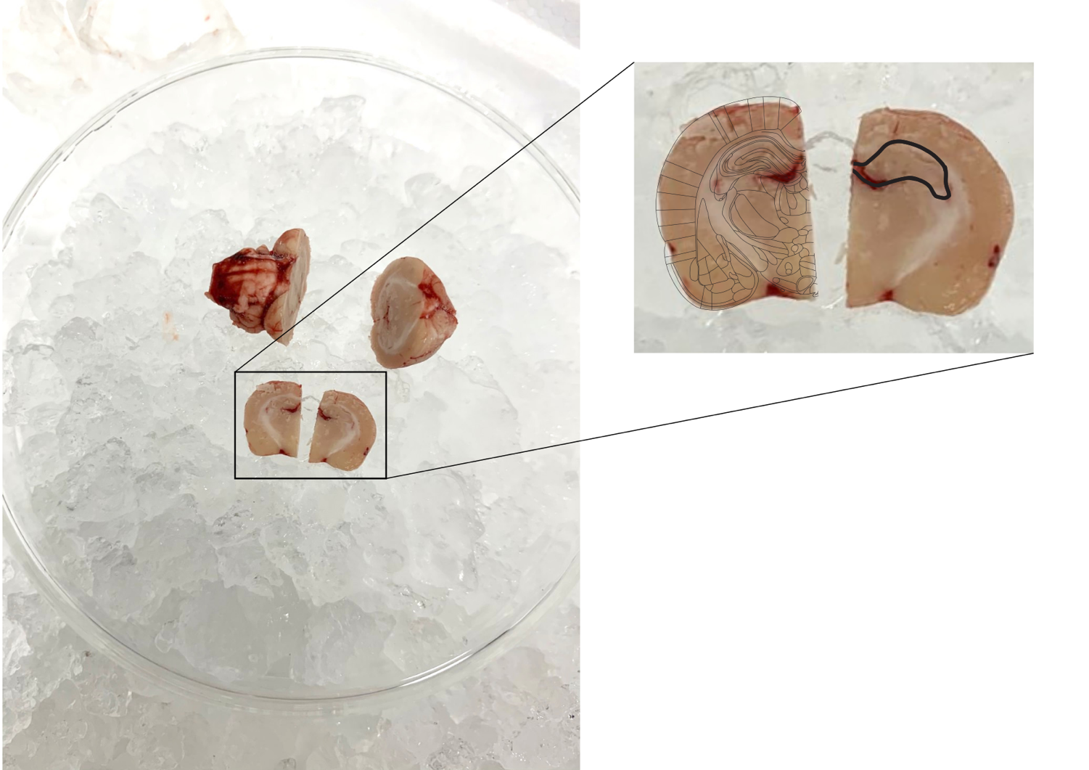

Fig. 1: brain dissection and sectioning performed over ice, and isolation of hippocampus

Liquid Chromatography-Mass Spectrometry (LC-MS):
We conducted our sample analysis using an Agilent Technologies 6530 Accurate-Mass Q-TOF mass spectrometer (MS) equipped with a Jet-Stream® electrospray ion (ESI) source, coupled with a 1260 Infinity liquid chromatography (LC) system (Agilent Technologies). For chromatographic separation, we used an InfinityLab Poroshell 120 SB-AQ column (2.1 x 100 mm, 2.7 μm particle size, Agilent) with a UHPLC Guard Poroshell pre-column (4.6 x 5 mm, 2.7 μm particle size, Agilent). The pre-column prevents large particles from clogging the system, and the column separates the sample solutions into components before reaching the MS, thereby improving accuracy and reliability while reducing excessive noise. The autosampler temperature was 4°C while the column temperature was maintained at 30°C. The flow rate was 0.35 mL/min, and the mobile phase consisted of water with 0.1% formic acid (eluent A) and ACN with 0.1% formic acid (eluent B). The total LC/MS run time was 24 minutes per sample and the gradient was as follows: 0-2 minutes 5-25% eluent B; 2-17 minutes, 25-70% eluent B; 17-20 minutes, 70-100% eluant B; 20-23 minutes, 100% eluent B; 23-24 minutes, 100-5% eluent B. The post-run time was set to 5 min, and the injection volume was 5 μL. Each batch of samples was run in positive and negative ionization modes to permit further comparison of metabolic profiles between samples and groups. The ESI MS settings were set to: gas temperature 275°C; gas flow 9 L/min; nebulizer 25 psig; capillary voltage 4,000 V; and nozzle voltage 500 V. The Q-TOF settings were set to: fragmentor voltage 140 V; mass range 100-1,500 m/z; acquisition rate 2 spectra/s; and acquisition time 500 ms/spectrum.
Ideally, we would have liked to prepare and run all our samples together to minimize the chance of sample degradation and MS signal drift between days. However, given the practical limitations of utilizing an LC/MS system shared by several schools, we had to split our samples into batches: 2 batches of 10 male samples each, and 2 batches of 11 female samples each. The run order for the male batches is detailed in Table 1.
1. | Machine blank
2. | MeOH blank
3. | Neurotransmitter standard mix
4. | QC
5. | QC
6. | QC
7. | QC
8. | QC
9. | Sample 1
10. | Sample 2
11. | Sample 3
12. | Sample 4
13. | Sample 5
14. | QC
15. | Sample 6
16. | Sample 7
17. | Sample 8
18. | Sample 9
19. | Sample 10
20. | QC
21. | QC
22. | MeOH blank
23. | Neurotransmitter standard mix
24. | Machine blank

Table 1: example of an LC/MS run order

The run order for the female batches was the same, apart from containing an extra sample in the second block. The first block of 5 QC samples was run in order to condition the system and monitor for any signal drift between them, as well as the QC samples in the middle and after the biological samples, as suggested in previous literature on sample run optimization (Broadhurst et al., 2018). The neurotransmitter solutions were included at the beginning and end of each run for the same reason: they permitted us to monitor signal drift with samples of known chemical compounds (Broadhurst et al., 2018). The MeOH blanks were included as a means of reducing extraneous noise by flushing any remaining particles out of the system before and after the run. Finally, the machine blanks cleaned the system.

Data Processing:
Raw data from each run was collected with Agilent MassHunter software and exported in .XML format with a noise threshold of 100. The raw data files were then imported into an open-source MS processing software platform, MZmine 2 (Pluskal et al., 2010). Initial settings for processing steps were taken from previous literature (Samra, 2015) as well as MZmine 2 user manuals, and optimized to suit the needs of our data sets specifically (Figure 2). Briefly, raw data files were analyzed with the mass detector function (noise level set to 100 to match raw data file export settings), and LC/MS chromatograms were constructed for each sample. Then, metabolic peaks were identified using the local minimum search function to create a list of peaks grouped by intensity, m/z ratio, and retention time; these chromatograms were then deconvoluted as a means of filtering for extraneous signals. Each sample’s deconvoluted chromatogram was then processed to group similar isotopes together, and then all chromatograms were aligned and combined to form a single data set for each group of batches. Finally, a duplicate peak filter was applied to the aligned list to remove duplicate peaks. This single data file for each group was then exported to Excel as a .csv file for further manual processing and comparison.
The manual processing procedure we used was adapted from Broadhurst and colleagues’ (2018) article addressing system suitability and quality control samples in untargeted metabolomics. The first step of the manual processing procedure was to calculate the percentage of contribution for each blank (Broadhurst et al., 2018). Next was to calculate the relative standard deviation (RSD) for the QC and biological samples by calculating the mean intensity and standard deviation for each peak detected (Broadhurst et al., 2018). Finally, the COUNT function was used to determine the number and percentage of QC and biological samples that a given metabolite feature had appeared in. After these calculations were performed, the dataset was filtered: all metabolite features with a blank contribution greater than 5% were deleted, as well as all features with a QC RSD greater than 20% (Broadhurst et al., 2018).
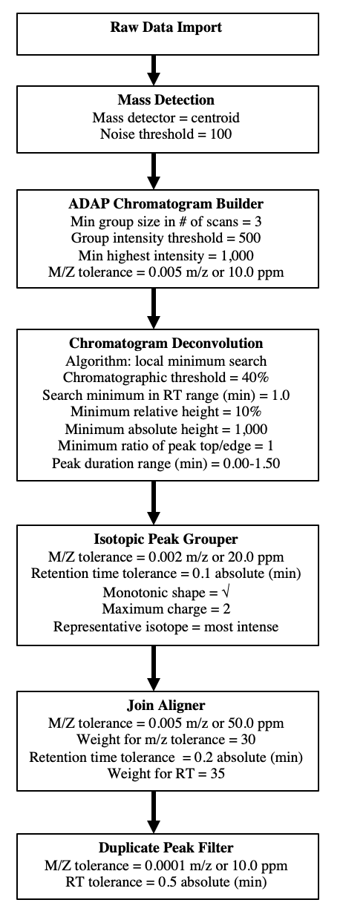
Further processing was performed using MetaboAnalyst, an online web server that utilizes R code for the processing and statistical analysis of metabolomics data sets (Pang et al., 2020; Chong et al., 2019; Chong et al., 2019; Chong & Xia, 2018; Chong et al., 2018; Xia & Wishart, 2016; Xia et al., 2015; Xia et al., 2013; Xia et al., 2012; Xia et al., 2011; Xia & Wishart, 2011; Xia & Wishart, 2010; Xia & Wishart, 2010; Xia et al., 2009). The program was used to normalize biological samples to the QC samples within gender and ESI groups, input missing values using the K-nearest neighbor (KNN) method, and scale the data using the pareto scaling function to permit multivariate analysis. These steps were taken from previously established recommended procedures for processing and interpreting metabolomics data (Broadhurst et al., 2018; Di Guida et al., 2016).
Like the final preparation protocol, this final processing procedure was the product of exhaustive optimization efforts; for a comprehensive and graphical explanation, please refer to the appendix A.

Fig. 2: itemized MZmine processing workflow
Statistical Analysis:
Statistical analysis was also performed using MetaboAnalyst. Initially, a principle components analysis (PCA) was performed in order to determine the degree of overall group separation and the metabolites that contributed to that separation. PCA is a simple, non-parametric, unsupervised statistical test that allows for identification and visualization of the metabolites that contribute most significantly to variance between samples (Nyamundanda et al., 2010). However, because it is unsupervised, it does not permit direct analysis of metabolites that contribute to separation between groups of samples. So, in order to directly test for potential differences between genotypes, a partial least squares-discriminative analysis (PLS-DA) was performed. PLS-DA is a supervised, multivariate regression method that is commonly used to classify and identify potential biomarkers from metabolomics data sets (Szymańska et al., 2011). Validation measures, including double cross validation and permutation testing, were performed post-hoc to ensure that the PLS-DA model was sufficiently optimized to permit significant conclusions to be drawn from the results (Szymańska et al., 2011).

Results
Data Processing Protocol
Three separate iterations of data processing procedures were applied to the raw data and discarded before arriving at the fourth and final protocol. Briefly, they were: processing each batch separately within ESI mode (positive/negative); processing batches together within ESI mode; processing batches separately within ESI mode and gender (male/female); and, finally, processing batches together within ESI mode and gender (please refer to appendix A for a more comprehensive description). Processing batches separately yielded substantial batch effects because variance in machine sensitivity between runs meant that very few metabolite features were detected in all samples. Thus, although processing batches separately tended to yield a greater number of total metabolites after applying the processing criteria outlined by Broadhurst and colleagues (2018), the percentage of missing values was also consistently higher. Unsurprisingly, estimating a substantial number of missing values led to greater batch effects.
The decision to process within ESI and gender rather than ESI mode alone was made for two reasons: first, only one metabolite feature met processing criteria for batches processed together within ESI mode; second, since each batch consisted of all male or female samples, gender could be a potential confound if not controlled for. Hence, the final processing procedure was born out of an attempt to negate both batch and confounding gender effects, while also striking a balance between maintaining a sufficient number of metabolite features that met significance criteria and minimizing the number of missing values that required imputation (Table 2).
 | # Metabolite Features | # Missing Values (% Total)
Separate within ESI
Positive | 443 | 9,674 (62.4%)
Negative | 390 | 8,893 (65.2%)
Together within ESI
Positive | 222 | 2,123 (27.3%)
Negative | 1 | 1 (2.9%)
Separate within ESI & Gender
Female Positive | 290 | 1,154 (23.4%)
Male Positive | 214 | 1,782 (46.3%)
Female Negative | 381 | 2,912 (45%)
Male Negative | 140 | 882 (35%)
Together within ESI & Gender
Female Positive | 151 | 77 (3%)
Male Positive | 10 | 22 (12.2%)
Female Negative | 23 | 28 (7.2%)
Male Negative | 39 | 40 (5.7%)

Table 2: number of metabolite features and missing values yielded by each processing protocol for each sample group

Final Protocol Results
Analysis of the raw data revealed that the internal standard signal was consistently reproduced between all samples and QCs within each batch, indicating that the m/z ratio, retention time, and detected concentration of metabolite features should be similarly consistent within batches. The neurotransmitter mix included in each batch was also nicely identified in each run, but since statistical analysis did not reveal anything conclusive, they could not be used to confirm feature identities.

Genotype
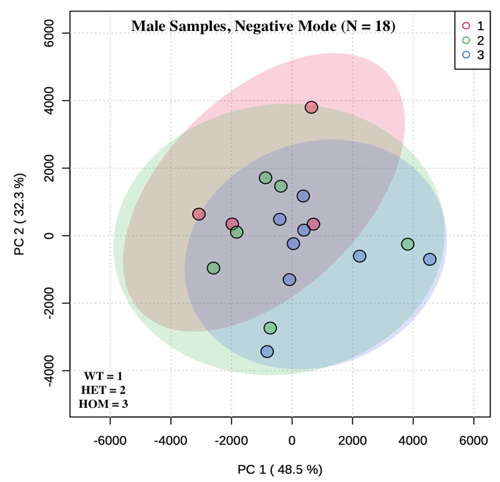
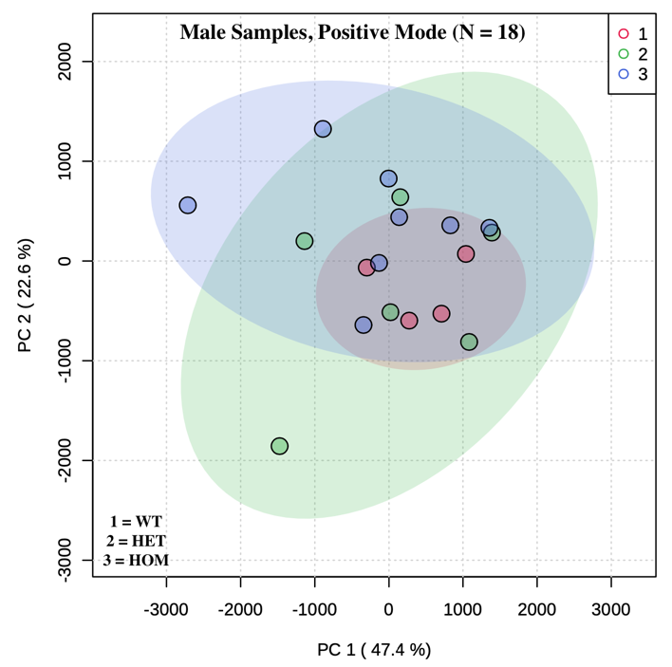
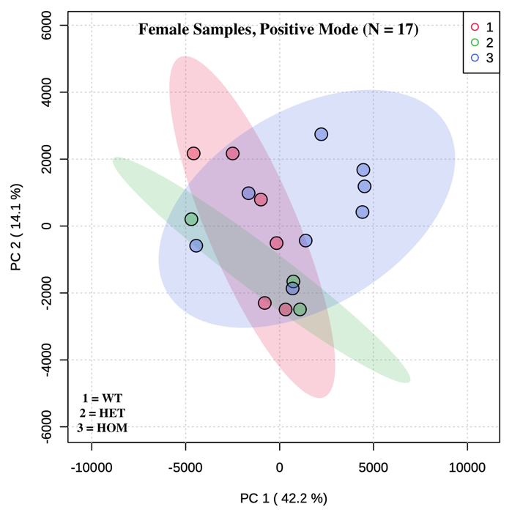
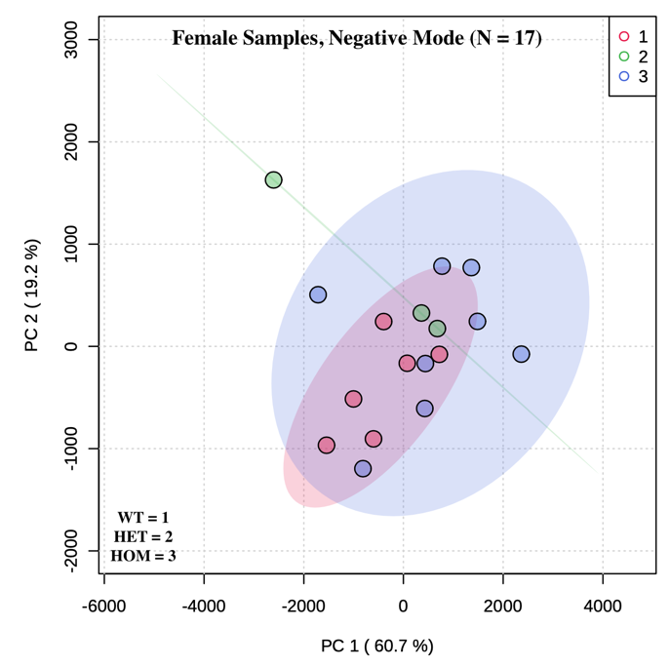
Four principle component analyses (PCAs) were performed, one for each gender group within ESI mode (Figure 3).

Fig. 3: 2D PCA scores plots by genotype

PCAs are a preliminary statistical visualization technique; therefore, no statistically significant inferences can be made about the data from PCAs alone. Ideally, the PCA would show clearly distinct groups of samples that differ in respect to the principle components; however, one can see from a visual inspection of these groups that there was a significant degree of overlap, which does not bode well for drawing statistically significant conclusions with supervised models. With that being said, there did seem to be a greater degree of variance for the HOM samples, particularly within the female groups.
To determine whether groups of samples differed significantly as a function of one or several individual components (i.e., metabolite features), 4 partial least squares-discriminative analysis (PLS-DA) regression models were created, one for each of the groups mentioned previously (Figure 4). Two validation measures were used to determine whether the models met goodness-of-fit criteria to be considered valid: the Q² value and permutation testing. The Q² is a default diagnostic statistic that is used to evaluate the degree of error between the predicted categorical variable and the known variable; results are considered significant if the Q² value is equal or nearly equal to 1 (Szymańska et al., 2011). Permutation testing involves the assignment of samples to random classification systems to determine whether random models explain the variance better than the constructed model. The test ultimately yields a p value, and the model is considered statistically robust if p < .05. (Szymańska et al., 2011). Neither the Q² nor the permutation p value (determined from 1,000 permutations) reached the level of significance for any of the models, so no statistically significant conclusions about variance in the data as a function of genotype could be made (Table 3).
Group | Q² | Permutation
Female Positive | Q² = 0.00 | p = 0.56
Male Positive | Q² = 0.00 | p = 0.36
Female Negative | Q² = -0.02 | p = 0.52
Male Negative | Q² = 0.03 | p = 0.37

Table 3: validation statistics for PLS-DA models constructed by genotype for each group of samples

Age
Despite the lack of a main effect with regards to genotype, including the 5 older samples originally discarded from the analysis of the female groups and grouping samples by age (i.e., 17 samples of 56-59 day-old rats in one group and 5 samples of 103-133 day-old rats in another) did reveal some interesting effects. While the PLS-DA validation measures still did not reach the level of significance (Table 4), a greater degree of separation between groups can be seen in the PCA and PLS-DA scores plots (Figures 4 and 5 respectively). This unexpected finding suggests the existence of a trend of age on metabolite constitution. The existence of a gender effect was not investigated in the male samples because only two male animals were significantly older than the rest.
Group | Q² | Permutation
Female Positive | Q² = 0.78 | p = 0.67
Female Negative | Q² = 0.73 | p = 0.28

Table 4: validation statistics for PLS-DA models constructed by sample age for the two groups of female samples

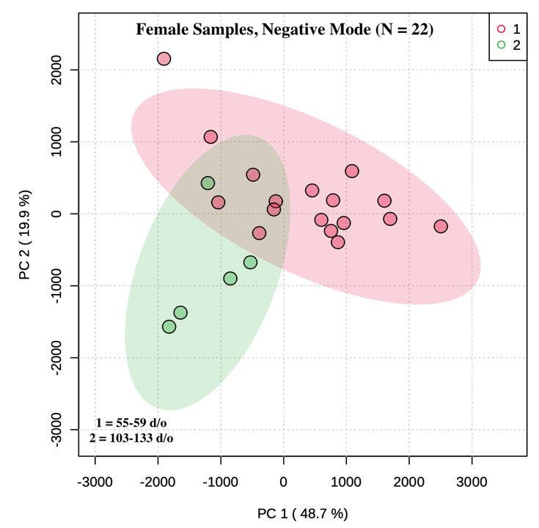
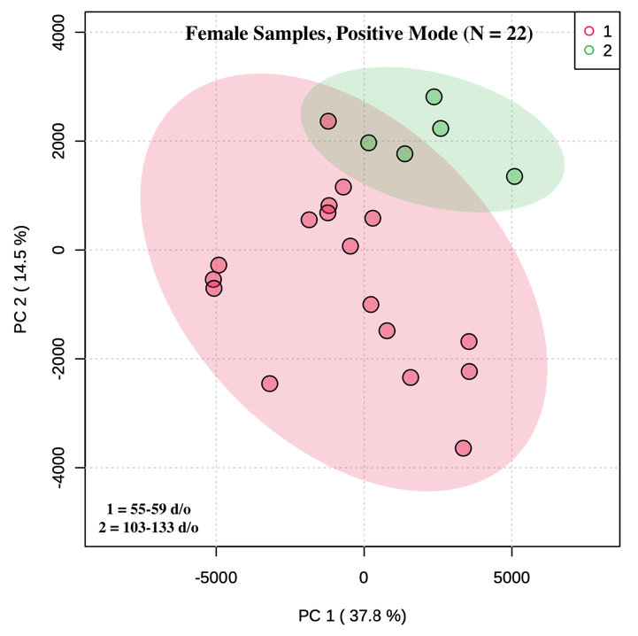
Fig. 4: 2D PCA scores plots by age
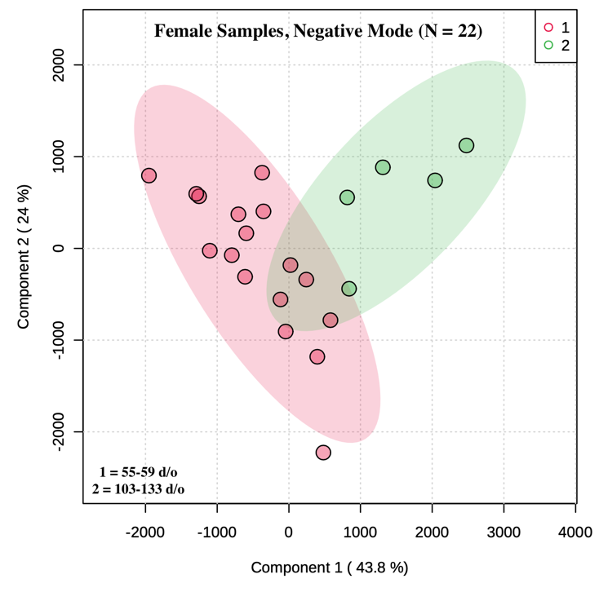
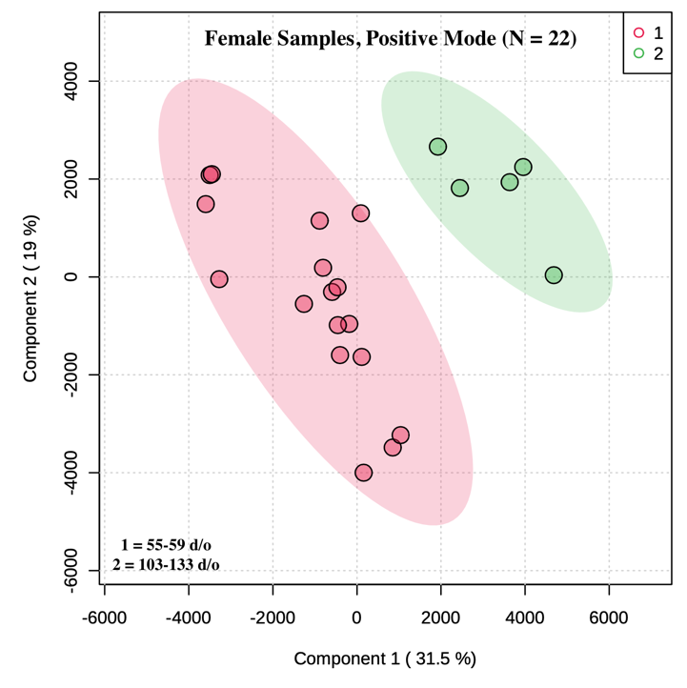

Fig. 5: 2D PLS-DA scores plots by age

Discussion
The goal of this study was to determine whether quantities of certain metabolites differed as a function of genotype in order to suggest specific biomarkers or metabolic pathways that might be differentially involved in animals with reduced or abolished SERT functioning. Following analysis, several iterations of data processing protocols were applied to the raw data, ultimately yielding a processing procedure that succeeded in mostly ameliorating the confounding batch effects originally observed. Despite these efforts, the study failed to find significant differences in metabolite concentrations between genotype groups, largely as a result of the technical issues that will be discussed in the limitations section. Interestingly, better dispersion between the female groups was found when the samples collected from older animals were included in the analysis and an effect of age rather than genotype was considered. While these statistical models still did not reach the level of significance, samples clustered to age groups more consistently than they clustered to genotype groups, particularly for samples analyzed in positive ionization mode.
This finding is consistent with previous research that has suggested an age-related impact on metabolic processes in various brain regions. Specifically, researchers have found that levels of glutathione (GSH) were higher in the hippocampi of late-aged rats (23-37 months), and may play a neuroprotective role in regards to Parkinson’s and Alzheimer’s disease (Durani et al., 2017). The same researchers also noted significant differences in the taurine metabolic pathway in the hippocampus, with reduced tauropine potentially contributing to age-related cognitive function decline and neurodegenerative disease (Durani et al., 2017). Another study demonstrated that age-related metabolic changes in the cortex, such as a reduction in acylcarnitines, differed substantially from those found in the hippocampus and thalamus, suggesting that metabolic changes as a function of age might be region specific (Zheng et al., 2016). Although the animals in these studies were significantly older than the animals in the current study, the findings are in agreement in suggesting that concentrations of certain metabolites fluctuate as a function of age.
Unfortunately, confirming whether the age-related dispersion of samples found in this study was related to the specific metabolic pathways identified in previous studies was beyond the scope of the project, given that statistical models still did not meet the goodness-of-fit threshold for metabolite identification. Furthermore, the focus of this study was on a main effect of genotype, and was therefore methodologically unsuitable and underpowered to determine an effect of age. Nonetheless, the findings highlight the salience of age as a potential confounding factor in future designs investigating metabolic differences between genotypes. On the other hand, with a properly designed methodology, examining interactional or additive effects of age and genotype could prove a fruitful avenue for future metabolomics research.

Strengths
The meticulous process of refining and optimizing the sample preparation procedure yielded a robust protocol. Our initial work was grounded in the methods of similar metabolomics studies that utilized homogenized rat brain tissue and LC/MS analysis (i.e., Nakayasu et al., 2016; Yoon et al., 2019). Through repeated testing, we optimized our protocol to prepare samples in such a way as to yield a comprehensive metabolic profile while also reducing extraneous noise. We then streamlined it to permit preparation of over half of our biological samples in a single day to prevent sample degradation. During the runs, we utilized a column and pre-column to facilitate separation and reduce contamination respectively. Finally, we employed a run order recommended by Broadhurst and colleagues (2018) that included periodic runs of the QC before, in the middle of, and after our biological samples in order to control for signal drift, and normalized our biological samples to the QC signals before statistical analysis (Broadhurst et al., 2018).

Limitations
Despite these methodological strengths, initial processing and statistical analysis of the sample groups revealed significant batch effects (see appendix A for further detail). Batch effects refer to uncontrolled sources of error, such as differences in laboratory/detection conditions, that cause an erroneous pattern to emerge that is not indicative of an actual relationship between the independent and dependent variables (Leek et al., 2010). These undesired effects are a frequently documented issue, not just in LC/MS-based metabolomics, but any protocol that utilizes an analytical technology platform (i.e., sequencing, microarrays, etc.) (Leek et al., 2010; Kuligowski et al., 2014). Because each batch consisted of either all female or male samples, gender had to be discarded as an independent variable because any effects observed would be indiscernible from batch effects. Once we decided to limit our analysis to a main effect of genotype, we combined the two batches for each gender in a final effort to yield a statistically significant model. However, while the final processing protocol did succeed in largely ameliorating the batch effects originally observed, the statistical models constructed still did not produce any significant results.
There are several explanations for why we encountered such significant batch effects and null results. In retrospect, if we had wanted to claim anything reliable as far as gender differences were concerned, we should have ensured that each batch was a mixture of both. However, even if we had mixed genders in each batch, we evidently still would have encountered batch effects and a lack of significant group dispersion, which is inherent to the analytical method used. Given that the machine is used quite frequently for a variety of qualitative and quantitative purposes, fluctuations in signal detection are to be expected, though not necessarily to the degree observed in our results. We also frequently observed substantial changes in system pressure between runs and had to re-run several batches because the pressure exceeded the maximum cutoff over the course of the run, which triggered an automatic machine shutdown. These fluctuations in running pressure could have changed some metabolite peak features. Another significant factor was periodic recalibration and maintenance performed by staff and other users between our runs, which inherently had an effect on detection and quantitation. Unfortunately, these were necessary functions, and could not have been delayed until after all of our analyses were complete.
These mechanical issues also undoubtedly contributed to the significant fluctuation in the number of metabolite features that survived Broadhurst and colleagues’ processing protocol between sample groups. When batches were run across two consecutive days, far more metabolites tended to meet significance criteria (particularly for samples analyzed in positive ionization mode) compared to batch runs that were separated by 7 days or more. This trend indicates that fluctuation in detection sensitivity over the course of our study was indeed a significant confound. The simplest option would have been to run all of our samples at one time or at least over consecutive days; however, given that the machine is a shared resource between several departments, this was not a realistic possibility.

Future directions
There are several methods by which future researchers could attempt to both ameliorate the batch effect and increase the likelihood of significant findings. Firstly, there are methodological or analytical changes that could be made. As stated previously, the easiest method would be to run all samples at one time. This could be achieved by developing a new method with a different column (i.e., different chemical properties and/or smaller particles) that would permit a shorter runtime, or by not including a column at all (i.e., direct infusion mass spectrometry). However, as discussed in the methods section, analyzing samples without a column risks poorer initial separation and detection. Another option would be to utilize an analytical method that permits faster analysis. Nuclear magnetic resonance (NMR), for instance, is less sensitive than LC/MS, but run times are usually considerably shorter (Zhang et al., 2012).
Secondly, there are processing steps that could be implemented in order to control for the batch effect. Including multiple QCs for each batch and normalizing biological samples to their respective QCs is recommended as the optimal way to control for batch effects (Wehrens et al., 2016). However, this processing step does not always ameliorate the effects if they are substantial, which was the case for our data. Thus, bioinformatics researchers have developed novel algorithms for metabolomics data processing in R that purportedly address these effects, even if normalizing to the QC has failed to do so (i.e., Deng et al., 2019). Unfortunately, employing such a complex algorithm that requires a substantial grounding in R coding was beyond the scope of the current study; but, given more time and resources, future projects could utilize such an algorithm if batch effects are otherwise insurmountable.

Conclusion
The current study employed an untargeted metabolomics methodology to determine whether significant differences in metabolite concentration could be found as a function of disrupted serotonin transporter functioning. If such a difference were to exist, it might serve as a potential biomarker for the depressive- and anxiety-like symptomology exhibited by the SERT KO rats, or elucidate the metabolic pathways that are most affected by the disruption. The hippocampi of HOM, HET, and WT animals were extracted and homogenized in MeOH, and analyzed using an LC/MS system. Raw data was extracted and processed using MZmine, Excel, and MetaboAnalyst, which was also used to create statistical models. Ultimately, despite considerable optimization and refinement efforts both in sample preparation and processing, statistical analysis did not reveal any individual metabolite features that differed as a function of genotype. Future researchers should be wary of the confounding impact of animal age and the batch effect, and should attempt to control for variations in machine calibration and usage over the course of the analysis. Despite the limited findings, future metabolomics projects will benefit from this study’s considerable contribution to optimizing sample preparation and data processing protocols.

References
American Psychiatric Association. (2013). Depressive Disorders. In Diagnostic and statistical
manual of mental disorders (DSM-5®) (7th ed.). American Psychiatric Pub. https://doi.org/10.1176/appi.books.9780890425596.dsm04
American Psychiatric Association. (2013). Anxiety Disorders. In Diagnostic and statistical
manual of mental disorders (DSM-5®) (7th ed.). American Psychiatric Pub. https://doi.org/10.1176/appi.books.9780890425596.dsm05
Benton, H. P., Wong, D. M., Trauger, S. A., & Siuzdak, G. (2008). XCMS2: Processing tandem mass spectrometry data for metabolite identification and structural characterization. Analytical Chemistry, 80(16), 6382-6389.
https://doi.org/10.1021/ac800795f
Broadhurst, D., Goodacre, R., Reinke, S. N., Kuligowski, J., Wilson, I. D., Lewis, M. R., & Dunn, W. B. (2018). Guidelines and considerations for the use of system suitability and quality control samples in mass spectrometry assays applied in untargeted clinical metabolomic studies. Metabolomics, 14(6). https://doi.org/10.1007/s11306-018-1367-3
Caspi, A., Sugden, K., Moffitt, T. E., Taylor, A., Craig, I. W., Harrington, H., McClay, J., Mill, J., Martin, J., Braithwaite, A., & Poulton, R. (2003). Influence of life stress on depression: Moderation by a polymorphism in the 5-HTT gene. Science, 301(5631), 386-389. https://doi.org/10.1126/science.1083968
Chong, J., Soufan, O., Li, C., Caraus, I., Li, S., Bourque, G., Wishart, D. S., & Xia, J. (2018). MetaboAnalyst 4.0: Towards more transparent and integrative metabolomics analysis. Nucleic Acids Research, 46(W1), W486-W494.
https://doi.org/10.1093/nar/gky310
Chong, J., & Xia, J. (2018). MetaboAnalystR: An R package for flexible and reproducible analysis of metabolomics data. Bioinformatics, 34(24), 4313-4314.
https://doi.org/10.1093/bioinformatics/bty528
Chong, J., & Xia, J. (2020). Using MetaboAnalyst 4.0 for Metabolomics data analysis, interpretation, and integration with other omics data. Computational Methods and Data Analysis for Metabolomics, 337-360. https://doi.org/10.1007/978-1-0716-0239-3_17
Chong, J., Yamamoto, M., & Xia, J. (2019). MetaboAnalystR 2.0: From raw spectra to biological insights. Metabolites, 9(3), 57. https://doi.org/10.3390/metabo9030057
Cole, J., Toga, A. W., Hojatkashani, C., Thompson, P., Costafreda, S. G., Cleare, A. J., Williams, S. C., Bullmore, E. T., Scott, J. L., & Mitterschiffthaler, M. T. (2010). Subregional hippocampal deformations in major depressive disorder. Journal of Affective Disorders, 126(1-2), 272-277. https://doi.org/10.1016/j.jad.2010.03.004
Coppen, A. (1967). The biochemistry of affective disorders. The British Journal of Psychiatry, 113(504), 1237-1264. https://doi.org/10.1192/bjp.113.504.1237
Deneris, E., & Gaspar, P. (2017). Serotonin Neuron development: Shaping molecular and structural identities. Wiley Interdisciplinary Reviews: Developmental Biology, 7(1), e301. https://doi.org/10.1002/wdev.301
Deng, K., Zhang, F., Tan, Q., Huang, Y., Song, W., Rong, Z., Zhu, Z., Li, K., & Li, Z. (2019). WaveICA: A novel algorithm to remove batch effects for large-scale untargeted metabolomics data based on wavelet analysis. Analytica Chimica Acta, 1061, 60-69.
https://doi.org/10.1016/j.aca.2019.02.010
Di Guida, R., Engel, J., Allwood, J. W., Weber, R. J., Jones, M. R., Sommer, U., Viant, M. R., & Dunn, W. B. (2016). Non-targeted UHPLC-MS metabolomic data processing methods: A comparative investigation of normalisation, missing value imputation, transformation and scaling. Metabolomics, 12(5). https://doi.org/10.1007/s11306-016-1030-9
Diémé, B., Lefèvre, A., Nadal-Desbarats, L., Galineau, L., Madji Hounoum, B., Montigny, F., Blasco, H., Andres, C. R., Emond, P., & Mavel, S. (2017). Workflow methodology for rat brain metabolome exploration using NMR, LC–MS and GC–MS analytical platforms. Journal of Pharmaceutical and Biomedical Analysis, 142, 270-278.
https://doi.org/10.1016/j.jpba.2017.03.068
Dunn, W. B., Broadhurst, D. I., Edison, A., Guillou, C., Viant, M. R., Bearden, D. W., & Beger, R. D. (2017). Quality assurance and quality control processes: Summary of a metabolomics community questionnaire. Metabolomics, 13(5).
https://doi.org/10.1007/s11306-017-1188-9
Durani, L. W., Hamezah, H. S., Ibrahim, N. F., Yanagisawa, D., Makpol, S., Damanhuri, H. A., & Tooyama, I. (2017). Age-related changes in the metabolic profiles of rat hippocampus, medial prefrontal cortex and striatum. Biochemical and Biophysical Research Communications, 493(3), 1356-1363.
https://doi.org/10.1016/j.bbrc.2017.09.164
Heffner, T. G., Hartman, J. A., & Seiden, L. S. (1980). A rapid method for the regional dissection of the rat brain. Pharmacology Biochemistry and Behavior, 13(3), 453-456.
https://doi.org/10.1016/0091-3057(80)90254-3
Homberg, J., Olivier, J., Smits, B., Mul, J., Mudde, J., Verheul, M., Nieuwenhuizen, O., Cools, A., Ronken, E., Cremers, T., Schoffelmeer, A., Ellenbroek, B., & Cuppen, E. (2007). Characterization of the serotonin transporter knockout rat: A selective change in the functioning of the serotonergic system. Neuroscience, 146(4), 1662-1676.
https://doi.org/10.1016/j.neuroscience.2007.03.030
Irie, M., Fujimura, Y., Yamato, M., Miura, D., & Wariishi, H. (2013). Integrated MALDI-MS imaging and LC–MS techniques for visualizing spatiotemporal metabolomic dynamics in a rat stroke model. Metabolomics, 10(3), 473-483.
https://doi.org/10.1007/s11306-013-0588-8
Jans, L., Lieben, C., & Blokland, A. (2007). Influence of sex and estrous cycle on the effects of
acute tryptophan depletion induced by a gelatin-based mixture in adult Wistar rats. Neuroscience, 147(2), 304-317. https://doi.org/10.1016/j.neuroscience.2007.04.028
Karg, K., Burmeister, M., Shedden, K., & Sen, S. (2011). The serotonin transporter promoter variant (5-HTTLPR), stress, and depression meta-analysis revisited: Evidence of genetic moderation. Archives of General Psychiatry, 68(5), 444-454.
https://doi.org/10.1001/archgenpsychiatry.2010.189
Kuligowski, J., Pérez-Guaita, D., Lliso, I., Escobar, J., León, Z., Gombau, L., Solberg, R., Saugstad, O., Vento, M., & Quintás, G. (2014). Detection of batch effects in liquid chromatography-mass spectrometry metabolomic data using guided principal component analysis. Talanta, 130, 442-448. https://doi.org/10.1016/j.talanta.2014.07.031
Leek, J. T., Scharpf, R. B., Bravo, H. C., Simcha, D., Langmead, B., Johnson, W. E., Geman, D., Baggerly, K., & Irizarry, R. A. (2010). Tackling the widespread and critical impact of batch effects in high-throughput data. Nature Reviews Genetics, 11(10),
733-739. https://doi.org/10.1038/nrg2825
Ma, Y., Li, B., Wang, C., Shi, Z., Sun, Y., Sheng, F., Zhang, Y., Zhang, W., Rao, Y., & Han, S.
(2013). 5-HTTLPR polymorphism modulates neural mechanisms of negative self-reflection. Cerebral Cortex, 24(9), 2421-2429. https://doi.org/10.1093/cercor/bht099
Mahar, I., Bambico, F. R., Mechawar, N., & Nobrega, J. N. (2014). Stress, serotonin, and hippocampal neurogenesis in relation to depression and antidepressant effects. Neuroscience & Biobehavioral Reviews, 38, 173-192.
https://doi.org/10.1016/j.neubiorev.2013.11.009
McKinnon, M. C., Yucel, K., Nazarov, A., & MacQueen, G. M. (2009). A meta-analysis examining clinical predictors of hippocampal volume in patients with major depressive disorder. Journal of Psychiatry and Neuroscience, 34(1), 41-54.
https://pubmed.ncbi.nlm.nih.gov/19125212/
Ministry of Health. (2019, November). Annual update of key results 2018/19: New Zealand Health Survey. https://www.health.govt.nz/publication/annual-update-key-results-2018-19-new-zealand-health-survey
Nakayasu, E. S., Nicora, C. D., Sims, A. C., Burnum-Johnson, K. E., Kim, Y., Kyle, J. E., Matzke, M. M., Shukla, A. K., Chu, R. K., Schepmoes, A. A., Jacobs, J. M., Baric, R. S., Webb-Robertson, B., Smith, R. D., & Metz, T. O. (2016). MPLEx: A robust and universal protocol for single-sample integrative Proteomic, Metabolomic, and Lipidomic analyses. mSystems, 1(3). https://doi.org/10.1128/msystems.00043-16
Nyamundanda, G., Brennan, L., & Gormley, I. (2010). Probabilistic principal component analysis for metabolomic data. BMC Bioinformatics, 11(1), 571.
https://doi.org/10.1186/1471-2105-11-571
Olivier, J., Van Der Hart, M., Van Swelm, R., Dederen, P., Homberg, J., Cremers, T., Deen, P., Cuppen, E., Cools, A., & Ellenbroek, B. (2008). A study in male and female 5-HT transporter knockout rats: An animal model for anxiety and depression disorders. Neuroscience, 152(3), 573-584.
https://doi.org/10.1016/j.neuroscience.2007.12.032
Pang, Z., Chong, J., Li, S., & Xia, J. (2020). MetaboAnalystR 3.0: Toward an optimized workflow for global Metabolomics. Metabolites, 10(5), 186.
https://doi.org/10.3390/metabo10050186
Peng, W., Chen, Z., Yin, L., Jia, Z., & Gong, Q. (2016). Essential brain structural alterations in major depressive disorder: A voxel-wise meta-analysis on first episode, medication-naive patients. Journal of Affective Disorders, 199, 114-123.
https://doi.org/10.1016/j.jad.2016.04.001
Pluskal, T., Castillo, S., Villar-Briones, A., & Orešič, M. (2010). MZmine 2: Modular framework for processing, visualizing, and analyzing mass spectrometry-based molecular profile data. BMC Bioinformatics, 11(1). https://doi.org/10.1186/1471-2105-11-395
Poliquin, P. O., Chen, J., Cloutier, M., Trudeau, L., & Jolicoeur, M. (2013). Metabolomics and in-silico analysis reveal critical energy deregulations in animal models of Parkinson’s disease. PLoS ONE, 8(7), e69146. https://doi.org/10.1371/journal.pone.0069146
Psychogios, N., Hau, D. D., Peng, J., Guo, A. C., Mandal, R., Bouatra, S., Sinelnikov, I., Krishnamurthy, R., Eisner, R., Gautam, B., Young, N., Xia, J., Knox, C., Dong, E., Huang, P., Hollander, Z., Pedersen, T. L., Smith, S. R., Bamforth, F., … Wishart, D. S. (2011). The human serum metabolome. PLoS ONE, 6(2), e16957.
https://doi.org/10.1371/journal.pone.0016957

Rhoades, S.D., & Weljie, A.M. (2016). Comprehensive optimization of LC-MS metabolomics methods using design of experiments (COLMeD). Metabolomics, 12(12). https://doi.org/10.1007/s11306-016-1132-4
Samra, S. N. (2015). Comparative evaluation of open access software used in liquid chromatography-mass spectrometry based untargeted metabolomics [Unpublished master's thesis]. Department of Chemistry, California State University.
Sharpley, C. F., Palanisamy, S. K., Glyde, N. S., Dillingham, P. W., & Agnew, L. L. (2014). An update on the interaction between the serotonin transporter promoter variant (5-HTTLPR), stress and depression, plus an exploration of non-confirming findings. Behavioural Brain Research, 273, 89-105.
https://doi.org/10.1016/j.bbr.2014.07.030
Smits, B. M., Mudde, J. B., Belt, J. V., Verheul, M., Olivier, J., Homberg, J., Guryev, V., Cools, A. R., Ellenbroek, B. A., Plasterk, R. H., & Cuppen, E. (2006). Generation of gene knockouts and mutant models in the laboratory rat by ENU-driven target-selected mutagenesis. Pharmacogenetics and Genomics, 16(3), 159-169.
https://doi.org/10.1097/01.fpc.0000184960.82903.8f
Szymańska, E., Saccenti, E., Smilde, A. K., & Westerhuis, J. A. (2011). Double-check: Validation of diagnostic statistics for PLS-DA models in metabolomics studies. Metabolomics, 8(S1), 3-16. https://doi.org/10.1007/s11306-011-0330-3
Tan, A., & Awaiye, K. (2013). Use of internal standards in LC-MS Bioanalysis. Handbook of LC-MS Bioanalysis, 217-227. https://doi.org/10.1002/9781118671276.ch17
Wehrens, R., Hageman, J. A., Van Eeuwijk, F., Kooke, R., Flood, P. J., Wijnker, E., Keurentjes, J. J., Lommen, A., Van Eekelen, H. D., Hall, R. D., Mumm, R., & De Vos, R. C. (2016). undefined. Metabolomics, 12(5). https://doi.org/10.1007/s11306-016-1015-8
World Health Organization. (2017, January). Depression and other common mental disorders:
global health estimates (No. WHO/MSD/MER/2017.2). https://www.who.int/publications/i/item/depression-global-health-estimates
Wirth, A., Holst, K., & Ponimaskin, E. (2017). How serotonin receptors regulate morphogenic signalling in neurons. Progress in Neurobiology, 151, 35-56.
https://doi.org/10.1016/j.pneurobio.2016.03.007
Xia, J., Broadhurst, D. I., Wilson, M., & Wishart, D. S. (2013). Translational biomarker discovery in clinical metabolomics: An introductory tutorial. Metabolomics, 9(2), 280-299. https://doi.org/10.1007/s11306-012-0482-9
Xia, J., Mandal, R., Sinelnikov, I. V., Broadhurst, D., & Wishart, D. S. (2012). MetaboAnalyst 2.0--a comprehensive server for metabolomic data analysis. Nucleic Acids Research, 40(W1), W127-W133. https://doi.org/10.1093/nar/gks374
Xia, J., Psychogios, N., Young, N., & Wishart, D. S. (2009). MetaboAnalyst: A web server for metabolomic data analysis and interpretation. Nucleic Acids Research, 37(Web Server), W652-W660. https://doi.org/10.1093/nar/gkp356
Xia, J., Sinelnikov, I. V., & Wishart, D. S. (2011). MetATT: A web-based metabolomics tool for analyzing time-series and two-factor datasets. Bioinformatics, 27(17), 2455-2456.
https://doi.org/10.1093/bioinformatics/btr392
Xia, J., Sinelnikov, I. V., Han, B., & Wishart, D. S. (2015). MetaboAnalyst 3.0—making metabolomics more meaningful. Nucleic Acids Research, 43(W1), W251-W257.
https://doi.org/10.1093/nar/gkv380
Xia, J., & Wishart, D. S. (2010). MetPA: A web-based metabolomics tool for pathway analysis and visualization. Bioinformatics, 26(18), 2342-2344.
https://doi.org/10.1093/bioinformatics/btq418
Xia, J., & Wishart, D. S. (2010). MSEA: A web-based tool to identify biologically meaningful patterns in quantitative metabolomic data. Nucleic Acids Research, 38(Web Server), W71-W77. https://doi.org/10.1093/nar/gkq329
Xia, J., & Wishart, D. S. (2011). Web-based inference of biological patterns, functions and pathways from metabolomic data using MetaboAnalyst. Nature Protocols, 6(6), 743-760. https://doi.org/10.1038/nprot.2011.319
Xia, J., & Wishart, D. S. (2011). Metabolomic data processing, analysis, and interpretation using MetaboAnalyst. Current Protocols in Bioinformatics, 34(1), 14.10.1-14.10.48.
https://doi.org/10.1002/0471250953.bi1410s34
Xia, J., & Wishart, D. S. (2016). Using MetaboAnalyst 3.0 for comprehensive Metabolomics data analysis. Current Protocols in Bioinformatics, 55(1), 14.10.1-14.10.91.
https://doi.org/10.1002/cpbi.11
Yoon, S. J., Long, N. P., Jung, K., Kim, H. M., Hong, Y. J., Fang, Z., Kim, S. J., Kim, T. J., Anh, N. H., Hong, S., & Kwon, S. W. (2019). Systemic and local metabolic alterations in sleep-deprivation-Induced stress: A Multiplatform mass-spectrometry-Based Lipidomics and Metabolomics approach. Journal of Proteome Research, 18(9), 3295-3304. https://doi.org/10.1021/acs.jproteome.9b00234
Zhang, H. F., Mellor, D., & Peng, D. H. (2018). Neuroimaging genomic studies in major depressive disorder: A systematic review. CNS Neuroscience and Therapeutics, 24(11), 1020-1036. https://doi.org/10.1111/cns.12829
Zhang, J., Bowers, J., Liu, L., Wei, S., Gowda, G. A., Hammoud, Z., & Raftery, D. (2012). Esophageal cancer metabolite biomarkers detected by LC-MS and NMR methods. PLoS ONE, 7(1), e30181. https://doi.org/10.1371/journal.pone.0030181
Zheng, X., Chen, T., Zhao, A., Wang, X., Xie, G., Huang, F., Liu, J., Zhao, Q., Wang, S., Wang, C., Zhou, M., Panee, J., He, Z., & Jia, W. (2016). The brain metabolome of male rats across the lifespan. Scientific Reports, 6(1). https://doi.org/10.1038/srep24125
Żmudzka, E., Sałaciak, K., Sapa, J., & Pytka, K. (2018). Serotonin receptors in depression and anxiety: Insights from animal studies. Life Sciences, 210, 106-124.
https://doi.org/10.1016/j.lfs.2018.08.050

Appendix A
Processing Optimization Process
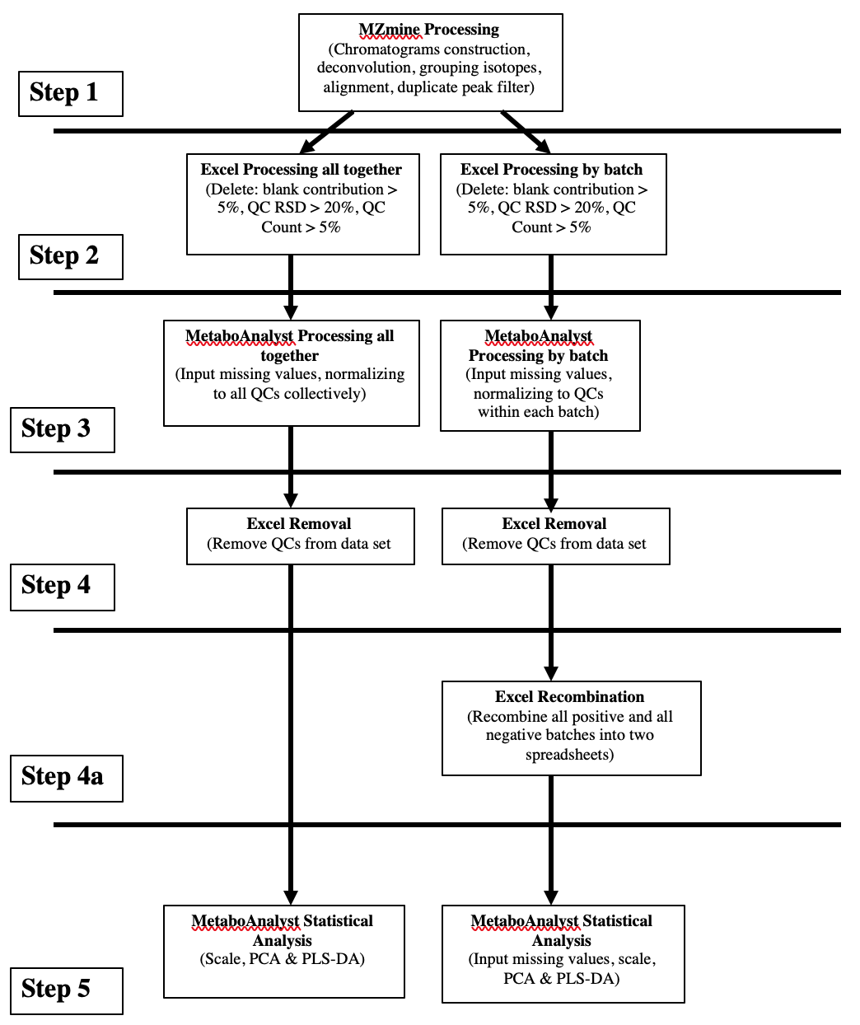
A considerable amount of time and effort went into optimizing the data processing protocol in an effort to maximize the potential for significant results. The workflow consisted of 5 steps: processing in MZmine, removal of extraneous features in Excel, initial processing in MetaboAnalyst, and final processing and statistical analysis, which was also conducted in MetaboAnalyst (Figure 5).

Fig. 5: data processing workflow
Initially, I processed and aligned all samples in MZmine to create two data sets: one for all samples from all batches analyzed in positive ESI mode, and one for all samples analyzed in negative mode. I then split these master sheets into 8 separate data sets, one for each batch. I removed features from each batch separately and also processed them in MetaboAnalyst separately, before recombining them back into two master sets by ESI mode and conducting statistical analysis (Figure 6). The benefit of this procedure was that it allowed me to remove features within each batch separately and normalize samples from each batch to their respective QCs. By processing the batches separately and recombining them before analysis, I was hoping to maximize the number of metabolite features that survived the removal criteria and more precisely adjust for signal drift between runs. However, as I recombined the batches, I realized that many features were only detected in one or two of the four batches within each master list. Not surprisingly, the results of the statistical analysis showed that genotype was not a meaningful group to explain differences between samples (Figure 7). Grouping samples by gender proved to be far more robust (Figure 8), but still not as robust as grouping samples by batch (Figure 9).
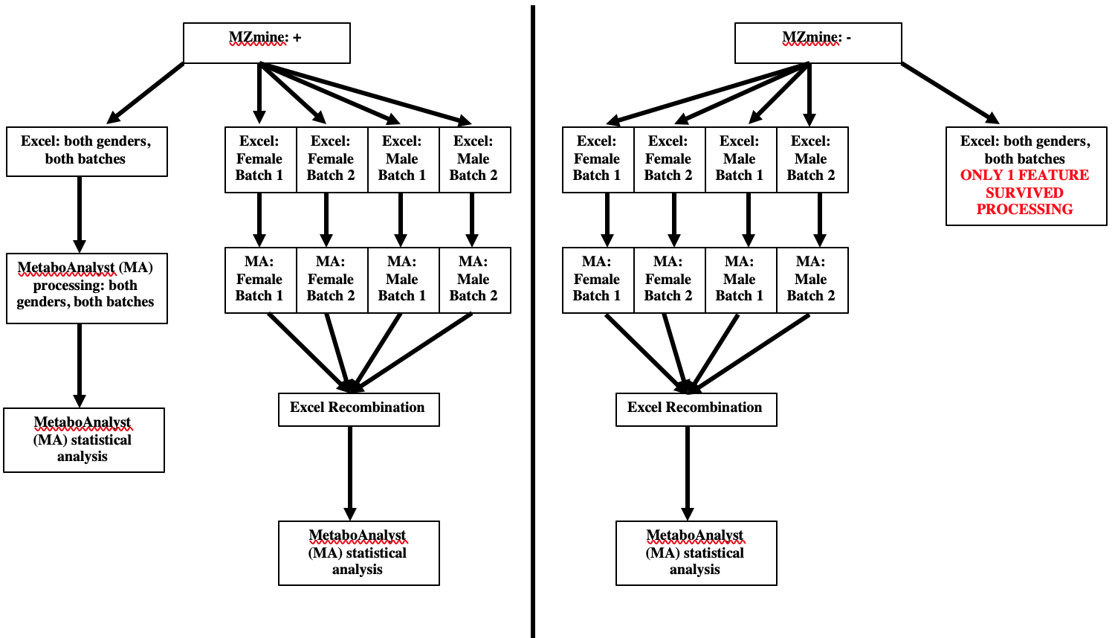

Fig. 6: Processing workflows for samples divided by ESI (processed separately vs. together)

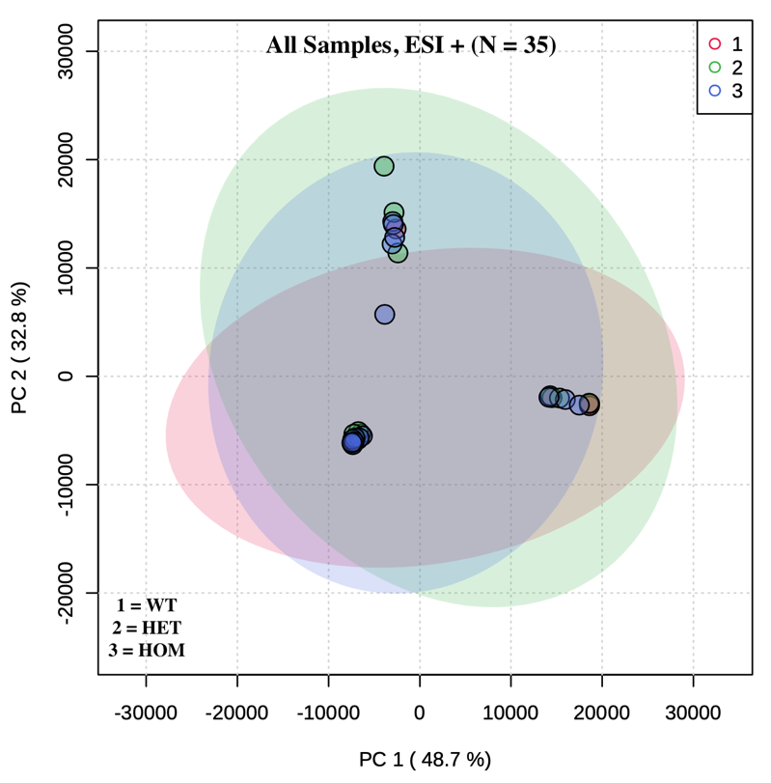
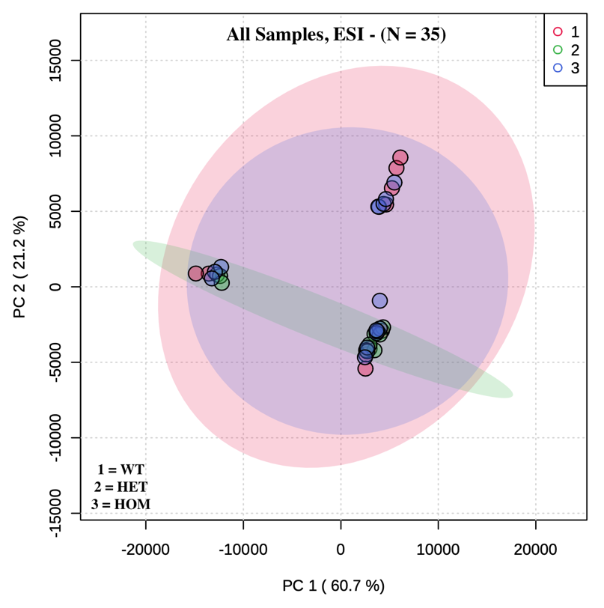

Fig. 7: 2D PCA scores plots by genotype (processed separately)

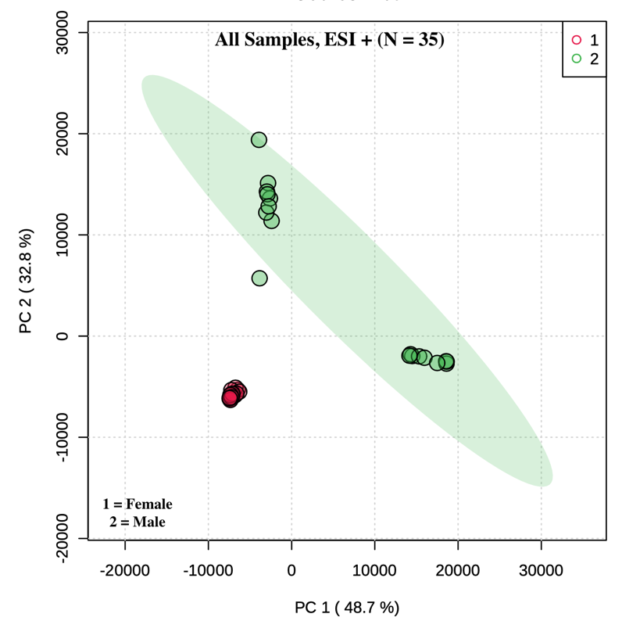
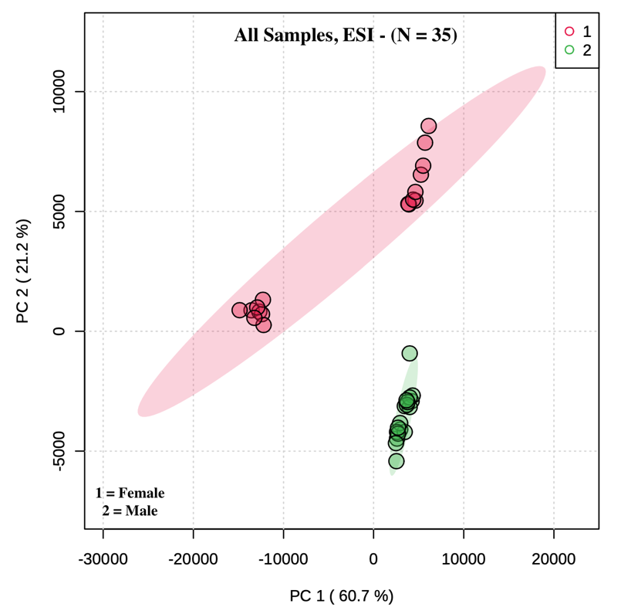

Fig. 8: 2D PCA scores plots by gender (processed separately)

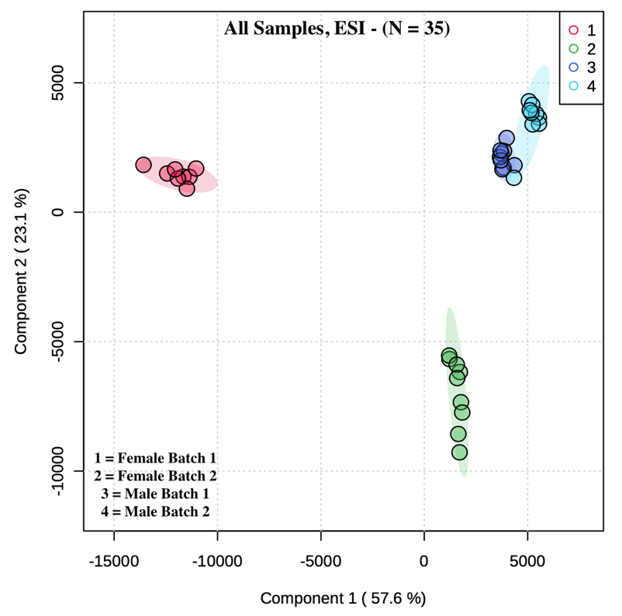
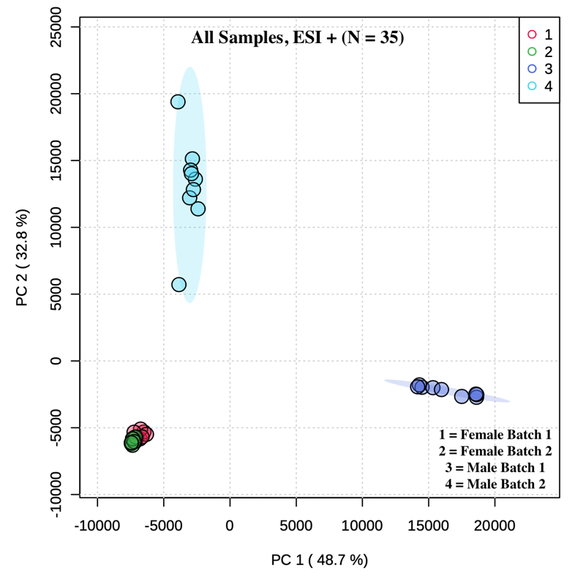
Fig. 9: 2D PCA scores plots by batch (processed separately)

In an attempt to negate these substantial batch effects, I then tried processing both master sets from MZmine (ESI + and ESI -) with all samples together, which meant removing extraneous features and normalizing samples to the pooled QCs from all runs (Figure 6). Unfortunately, only 1 metabolite feature from the negative data set survived the removal criteria, so this processing procedure had to be abandoned.
Evidently, processing samples by ESI analysis mode was not going to yield significant results by genotype. Even if differences by genotype were in fact present, statistical models resulting from this workflow would be thoroughly stymied by the substantial batch effects. Therefore, I decided to process samples in MZmine by gender within ESI mode. This protocol meant that I could no longer look for significant effects and interactions of gender; but, since gender was fairly confounded by the batch effect anyway (because batches were separated by gender), I decided the loss of potential explanatory power was not substantial. MZmine processing yielded 4 master data sets, each consisting of 2 batches: female positive, male positive, female negative, and male negative. As with the previous workflow, my first attempt was to process each batch separately and recombine them before statistical analysis (Figure 10). Once again, as I recombined batches, I noticed that many features only appeared in samples from one batch. Statistical analysis of these groups confirmed this initial observation and revealed significant batch effects once again (Figures 11 and 12).
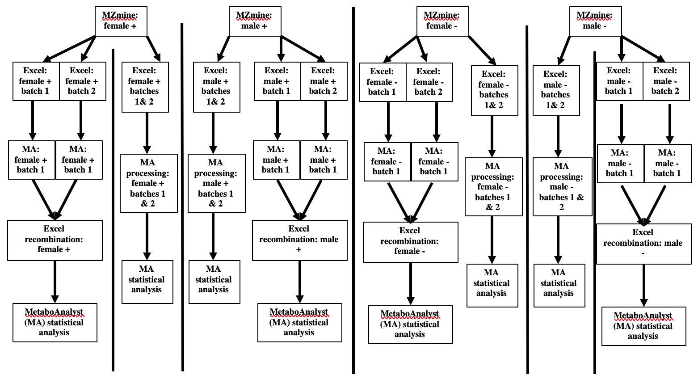

Fig. 10: Processing workflows for samples divided by ESI and gender (processed separately vs. together)

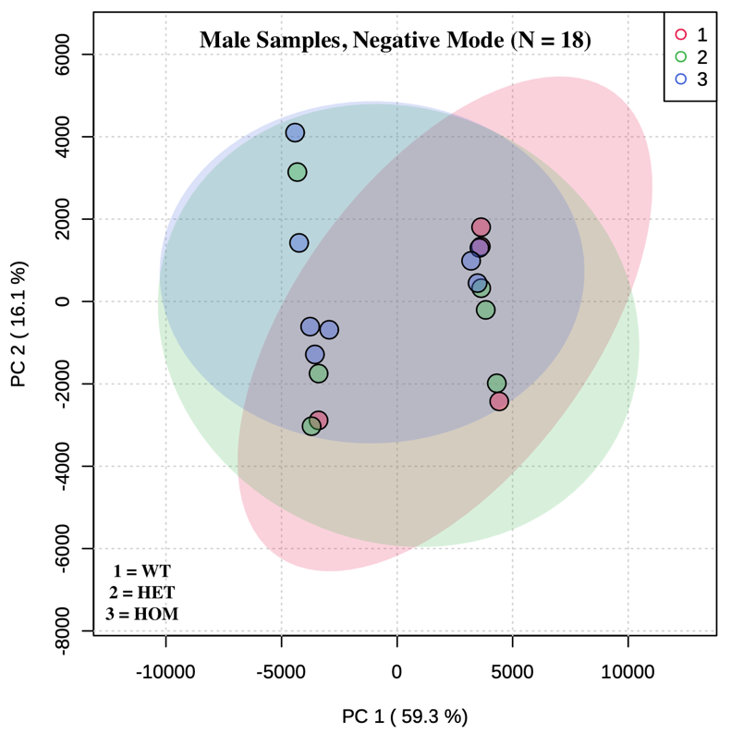
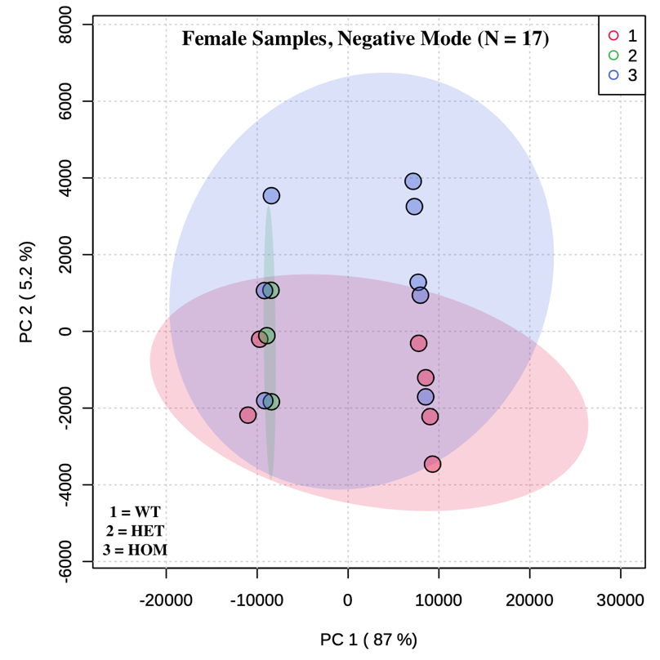
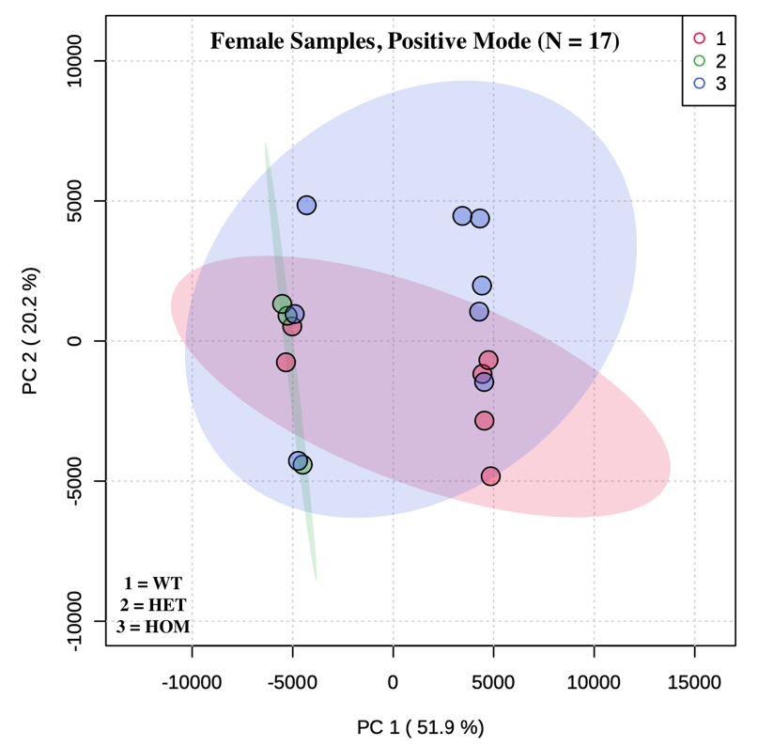
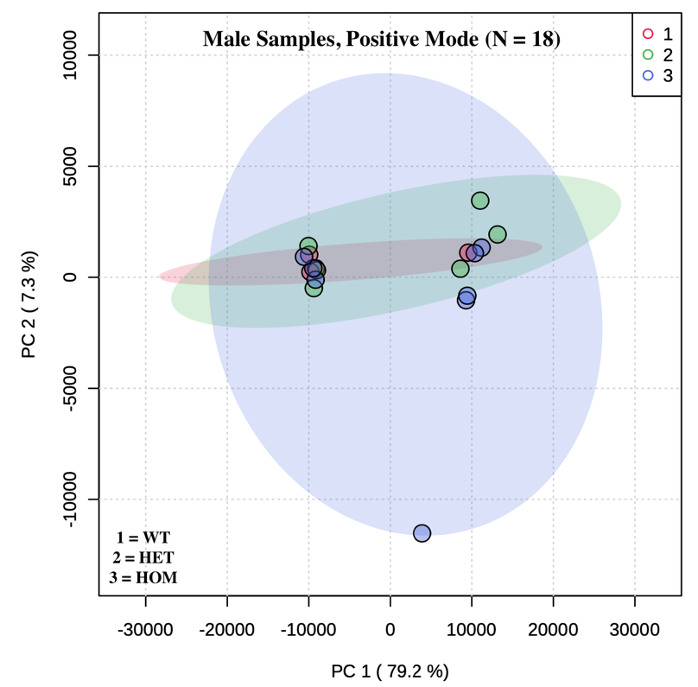
Fig. 11: 2D PCA scores by genotype (processed separately)

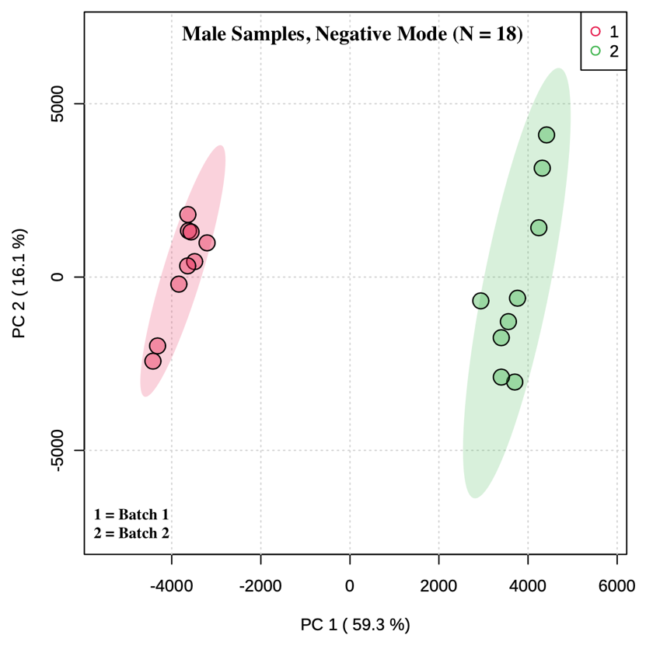
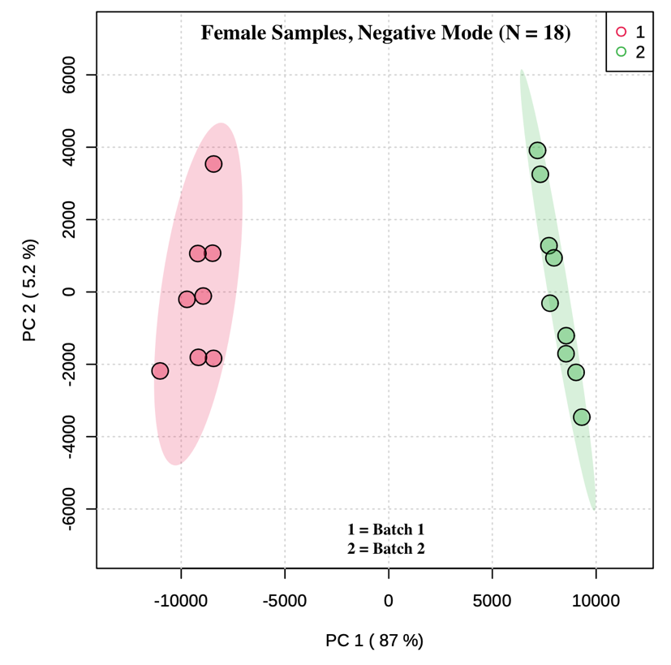
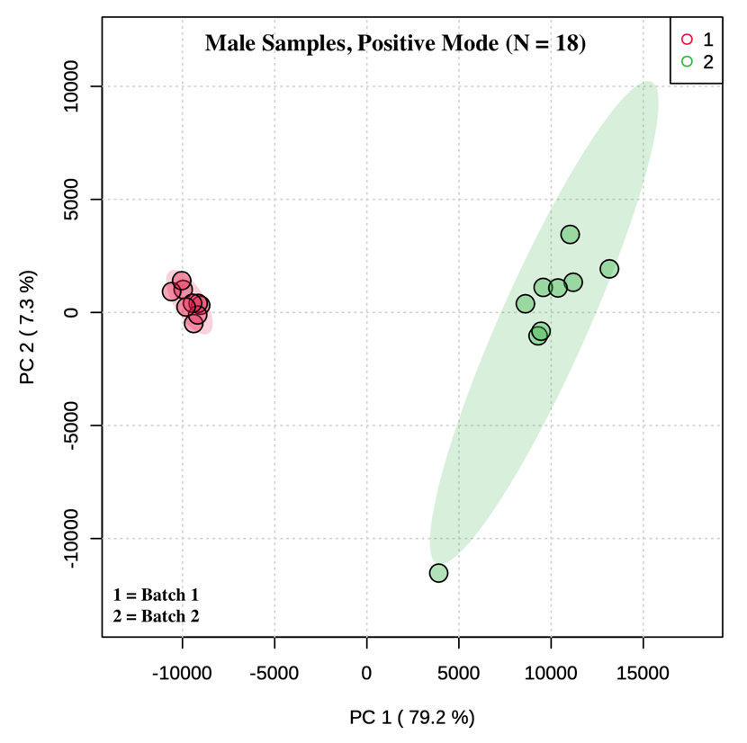
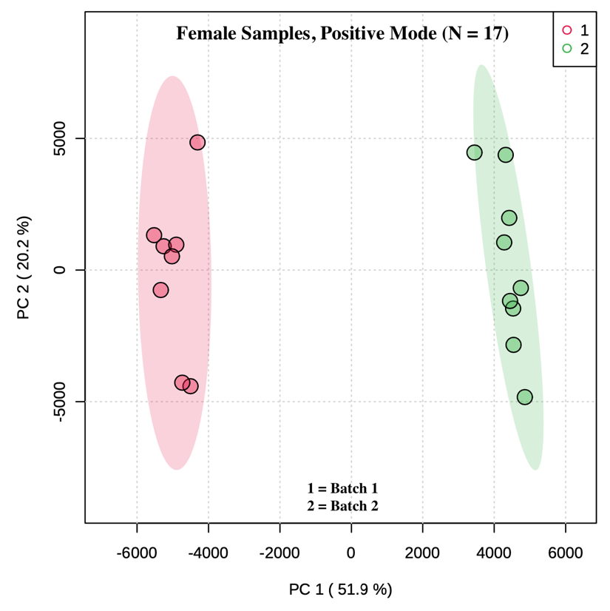
Fig. 12: 2D PCA scores by batch (processed separately)

Thus, in the final workflow, batches were kept in their ESI- and gender-based groups of two (i.e., both batches of female positive, both batches of female negative, etc.) for feature removal in Excel, and samples were normalized to QCs from both batches. Although this technique proved largely successful in ameliorating the batch effect (Figure 13), the samples still did not robustly differ as a function of genotype (see results section). As mentioned previously, adding the 5 older samples back into the female groups and analyzing by age did yield a somewhat more robust group separation, but these models still did not reach the level of significance. Based on this workflow optimization process, future metabolomics studies should be wary of processing batches separately and then recombining before analysis, as this method seems to exacerbate the batch effect issue.

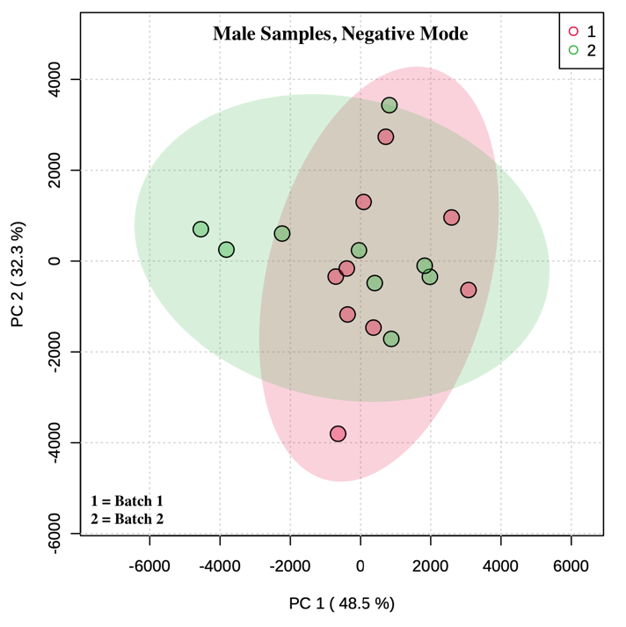
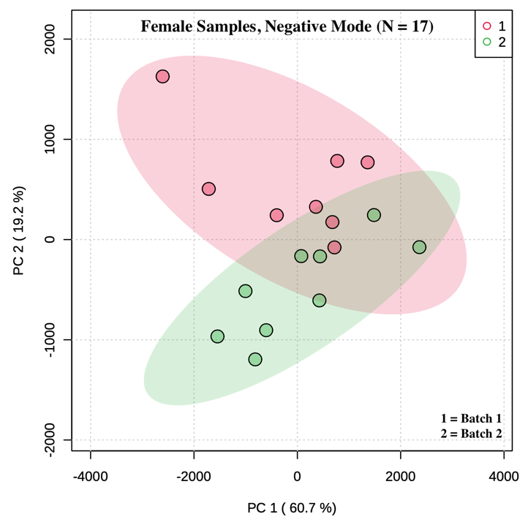
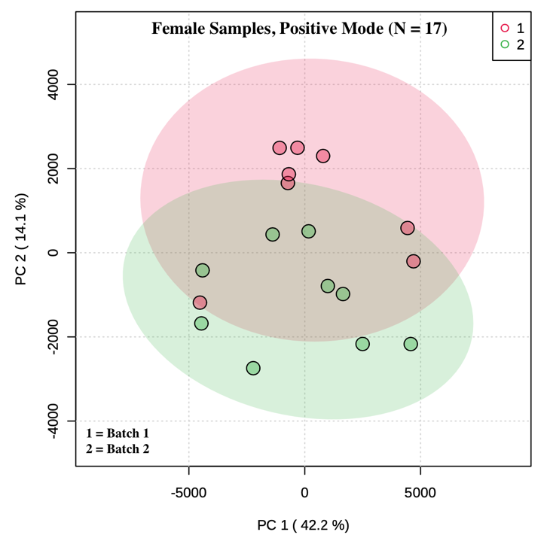
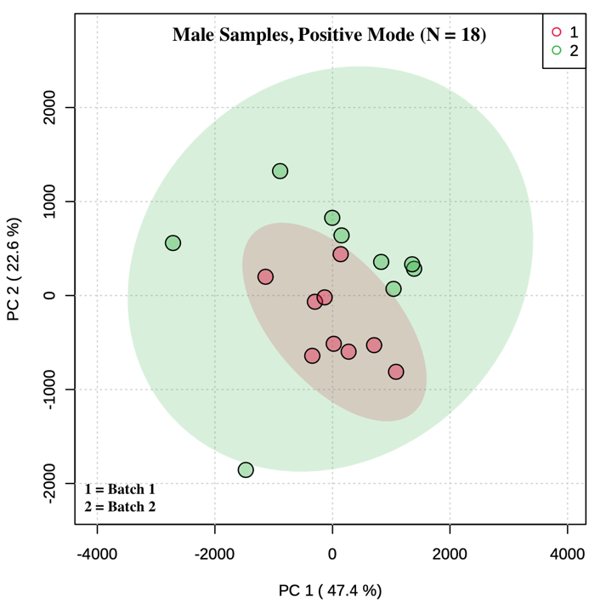

Fig. 13: 2D PCA scores by batch (processed together)

